PRESS RELEASE
Würth Elektronik hosts the virtual “WE meet @ digital days 2022” conference
A four-day-long event: profound electronics expertise for developers
Waldenburg (Germany), February 2, 2022—From 21 until 24 February 2022, for the fourth time Würth Elektronik will be hosting its virtual technical conference, the “WE meet @ digital days” event. On each of these days, from 9:00am until 5:00pm the electronics specialist will once again be presenting an extensive and varied programme, with high-quality presentations on EMC, power management and electromechanics, wireless power, LED technology, and many other exciting topics besides. In-depth interactive Q&A sessions on the presentations, which will be held in English, will be just as much part of the programme as the presentation of state-of-the-art developments and trends by renowned Würth Elektronik specialists as well as guest lectures given by partner companies. All information on the programme, which is free of charge for the visitors, and on how to register for attendance can be found at the address www.we-online.com/digital-days.
“When we launched our virtual WE meet @ digital days conference in 2020, we put our finger on the pulse of the times, succeeding in offering developers a perfect forum as an alternative stage for the exchange of ideas and opinions under the difficult conditions posed by the corona crisis. Meanwhile, this event has established itself as a fixture in the calendar of our large community of users and developers alike,” explains Alexander Gerfer, CTO of the Würth Elektronik eiSos Group.
“more than you expect!” – our motto and programme
With the WE meet @ digital days event, Würth Elektronik offers developers a unique opportunity to gain formation for themselves on the current technological status and future developments in a compact format: this year’s event will include a total of 27 presentations, spread over a four-day period. On top of this, participants will be able to draw a profit for their everyday operations from numerous in-depth practical tips, background information, and application examples from very different technical areas. The presentations and papers will be hosted by the experts from the individual product divisions within the Würth Elektronik organization, for example Passive & Electromechanical Components, Power Modules & Optoelectronics, Automotive, Frequency Products, and Wireless Connectivity & Sensors, and Custom Magnetics. Informative guest presentations this year will be given by the companies Microchip Technology and onsemi on the aspects of Secondary-Side Compensation for Isolated Power Supplies and Meeting Challenging Efficiency Standards with Bridgeless Totem Pole Power Factor Correction.
Each of the technical presentations is timed to last approximately 30 minutes, and a special chat function is provided to enable you to contact the competent Würth Elektronik specialists directly. Each presentation will be immediately followed by an extensive Q&A session, in which the participants will be able to get direct answers to any detailed questions they may have.
Register today!
Registration for the free-of-charge virtual WE meet @ digital days conference is now open immediately, and all presentations can be individually booked.
For more details on the conference programme with the individual topic areas and to register for attendance, please go to the central address www.we-online.com/digital-days.

Available images
The following images can be downloaded from the Internet in printable quality: https://kk.htcm.de/press-releases/wuerth/
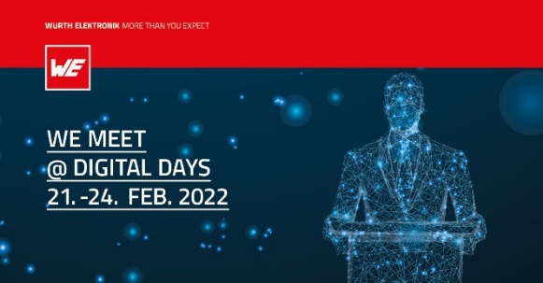  Image source: Würth Elektronik  WE meet @ digital days from 21 to 24 February 2022 – four days crammed full of know-how of the electronics specialist Würth Elektronik | 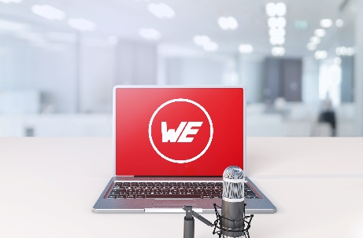Image source: Würth Elektronik  WE meet @ digital days 2022 offers a total of 27 expert presentations followed by Q&A sessions - virtually and from the comfort of your desk.

About the Würth Elektronik eiSos Group
Würth Elektronik eiSos Group is a manufacturer of electronic and electromechanical components for the electronics industry and a technology company that spearheads pioneering electronic solutions. Würth Elektronik eiSos is one of the largest European manufacturers of passive components and is active in 50 countries. Production sites in Europe, Asia and North America supply a growing number of customers worldwide.
The product range includes EMC components, inductors, transformers, RF components, varistors, capacitors, resistors, quartz crystals, oscillators, power modules, Wireless Power Transfer, LEDs, sensors, connectors, power supply elements, switches, push-buttons, connection technology, fuse holders and solutions for wireless data transmission.
The unrivaled service orientation of the company is characterized by the availability of all catalog components from stock without minimum order quantity, free samples and extensive support through technical sales staff and selection tools.
Würth Elektronik is part of the Würth Group, the world market leader for assembly and fastening technology. The company employs 7,300 staff and generated sales of 823 million euros in 2020.
Würth Elektronik: more than you expect!
Further information at www.we-online.com

Further information:  Würth Elektronik eiSos GmbH & Co. KG  Sarah Hurst  Max-Eyth-Strasse 1  74638 Waldenburg  Germany  Phone: +49 7942 945-5186  E-mail: sarah.hurst@we-online.de  www.we-online.com | Press contact:  HighTech communications GmbH  Brigitte Basilio  Brunhamstrasse 21  81249 Munich  Germany  Phone: +49 89 500778-20  Telefax: +49 89 500778-77  E-mail: b.basilio@htcm.de  www.htcm.de

