PRESS RELEASE
Würth Elektronik publishes additional Application Note on Supercapacitors
Design-in support for supercapacitor applications
Waldenburg (Germany), February 3, 2022—Under the title "Always in balance - Balancing supercapacitors", Würth Elektronik provided a new help guide for developers on its homepage. The latest publication includes experience gained from support and addresses the relative unfamiliarity of using supercapacitors. This extends the support Würth Elektronik has previously provided in the form of application notes, explanatory videos and webinars.
Although supercapacitors, such as the Würth Elektronik WCAP-STSC series, essentially differ from other capacitors only in their higher energy density, they unlock completely different applications. Würth Elektronik's product management team has made it its business to assist developers, especially in the application of capacitors as energy storage devices, with concepts, selection criteria and calculation bases.
Whether preventing data loss in the event of a power failure, for critical network devices or in medical technology - supercapacitors are durable components for short-term power supply. Application Note ANP090: Keep the balance - balancing supercapacitors addresses the issue that supercapacitors normally operate at voltages of around 2.7 V. To achieve higher operating voltages, a cascade of supercapacitor cells connected in series is required. Fluctuations in capacitance and insulation resistance due to manufacturing or aging make voltage equalization (balancing) necessary. The application note by René Kalbitz, Product Manager, and Frank Puhane, Technical Engineering Leader, at Würth Elektronik eiSos for the capacitors division, covers the theoretical background, measurements and practical examples while offering various balancing concepts.
All texts and videos on the topic of supercondesators are linked on the product page WCAP-STSC.
Additionally, Würth Elektronik offers the ABC of Capacitors, a technical book that provides an introduction to capacitor technology.

Available images
The following images can be downloaded from the Internet in printable quality: https://kk.htcm.de/press-releases/wuerth/
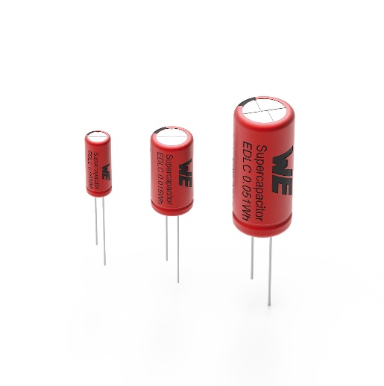Source: Würth Elektronik
When using supercapacitors such as the WCAP-STSC, additional factors are important compared to conventional capacitors. Würth Elektronik supports developers with application notes and design-in support.

About the Würth Elektronik eiSos Group
Würth Elektronik eiSos Group is a manufacturer of electronic and electromechanical components for the electronics industry and a technology company that spearheads pioneering electronic solutions. Würth Elektronik eiSos is one of the largest European manufacturers of passive components and is active in 50 countries. Production sites in Europe, Asia and North America supply a growing number of customers worldwide.
The product range includes EMC components, inductors, transformers, RF components, varistors, capacitors, resistors, quartz crystals, oscillators, power modules, Wireless Power Transfer, LEDs, sensors, connectors, power supply elements, switches, push-buttons, connection technology, fuse holders and solutions for wireless data transmission.
The unrivaled service orientation of the company is characterized by the availability of all catalog components from stock without minimum order quantity, free samples and extensive support through technical sales staff and selection tools.
Würth Elektronik is part of the Würth Group, the world market leader for assembly and fastening technology. The company employs 8,000 staff and generated sales of 1.09 Billion Euro in 2021.
Würth Elektronik: more than you expect!
Further information at www.we-online.com

Further information:  Würth Elektronik eiSos GmbH & Co. KG  Sarah Hurst  Max-Eyth-Strasse 1  74638 Waldenburg  Germany  Phone: +49 7942 945-5186  E-mail: sarah.hurst@we-online.de  www.we-online.com | Press contact:  HighTech communications GmbH  Brigitte Basilio  Brunhamstrasse 21  81249 Munich  Germany  Phone: +49 89 500778-20  Telefax: +49 89 500778-77  E-mail: b.basilio@htcm.de  www.htcm.de

