PRESS RELEASE
Würth Elektronik extends its MagI³C VDMM family with 36 V versions
Power Module Meets the Requirements of the 24 V Industrial Voltage Network
Waldenburg (Germany), July 5, 2022—A new generation of MagI³C VDMM power modules: The Variable Step Down MicroModules now cover all bus voltages from 3.3 V through 24 V Applications include Point-of-Load Converters or a direct connection to the 24V bus. The ultra-wide input voltage ranges up to 36 V makes the MicroModule robust against voltage transients on the 24 V bus. The MicroModule has been optimized for space-limited applications and therefore comes in the compact LGA-8 package. The adjustable output voltage ranges from 1 V to 6 V with a current up to 0.3 A.
The MagI³C-VDMM series is a clear favorite for replacing linear regulators. Applications include supplying interfaces, microcontrollers, microprocessors, DSPs and FPGAs. Thanks to their small package size and high efficiency (up to 87%), they are particularly suitable for use in mobile and battery-powered devices. To save energy, the power module can be set to sleep mode using an additional pin.
Würth Elektronik undertook its own pre-compliance measurements to verify filter combinations and ascertained that the interference radiated and conducted from the modules is below the limit of EMC standard EN55032/CISPR32 Class B.
The new member of the MagI³C-VDMM family is available from stock. Free samples can be requested.

Available images
The following images can be downloaded from the Internet in printable quality: https://kk.htcm.de/press-releases/wuerth/

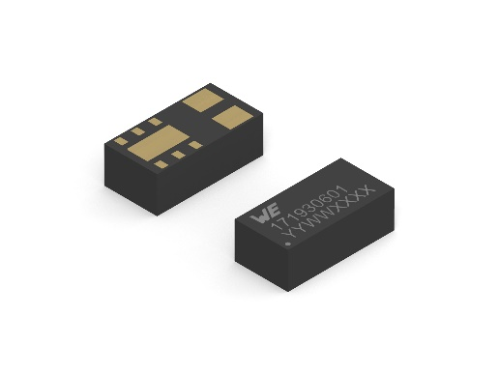
Image source: Würth Elektronik
MagI³C-VDMM Variable Step Down MicroModule

About the Würth Elektronik eiSos Group
Würth Elektronik eiSos Group is a manufacturer of electronic and electromechanical components for the electronics industry and a technology company that spearheads pioneering electronic solutions. Würth Elektronik eiSos is one of the largest European manufacturers of passive components and is active in 50 countries. Production sites in Europe, Asia and North America supply a growing number of customers worldwide.
The product range includes EMC components, inductors, transformers, RF components, varistors, capacitors, resistors, quartz crystals, oscillators, power modules, Wireless Power Transfer, LEDs, sensors, connectors, power supply elements, switches, push-buttons, connection technology, fuse holders and solutions for wireless data transmission.
The unrivaled service orientation of the company is characterized by the availability of all catalog components from stock without minimum order quantity, free samples and extensive support through technical sales staff and selection tools.
Würth Elektronik is part of the Würth Group, the world market leader for assembly and fastening technology. The company employs 8,000 staff and generated sales of 1.09 Billion Euro in 2021.
Würth Elektronik: more than you expect!
Further information at www.we-online.com

Further information:  Würth Elektronik eiSos GmbH & Co. KG  Sarah Hurst  Max-Eyth-Strasse 1  74638 Waldenburg  Germany  Phone: +49 7942 945-5186  E-mail: sarah.hurst@we-online.de  www.we-online.com | Press contact:  HighTech communications GmbH  Brigitte Basilio  Brunhamstrasse 21  81249 Munich  Germany  Phone: +49 89 500778-20  Telefax: +49 89 500778-77  E-mail: b.basilio@htcm.de  www.htcm.de

