The next bottleneck has arrived: AI boom intensifies PCB material shortages

While the electronics industry has focused primarily on semiconductors in recent years, the next critical supply bottleneck has already emerged in the background: PCB base materials are becoming scarce worldwide.
The primary driver is the rapid expansion of AI data centers and high-performance computing systems. These applications require enormous quantities of high-grade laminates, significantly reducing available production capacity for traditional industrial and automotive applications. The layer count of PCBs used in AI servers is three to five times higher than that of conventional designs. As a result, demand for high-quality PCB materials is increasing substantially throughout the entire supply chain. Industry experts expect demand to remain at a very high level, or continue to grow, at least through the end of 2026.

A particular challenge is the simultaneous shortage of several key raw materials required for PCB manufacturing. In addition to copper-clad laminates (CCL), supply pressure is increasingly affecting copper foils, prepregs (especially PP1080 and PP2116), high-performance resin, and other materials such as tungsten carbide used for drilling and routing tools. For fiberglass fabrics, industry experts do not anticipate any significant easing of supply constraints before 2028.

The consequences include rising prices, longer lead times, reduced price predictability, and stricter allocation measures across parts of the supply chain. At the same time, flexibility in responding to short-term demand fluctuations is declining, as production capacities at many manufacturers have already been committed for the long term.

As a result, the market is undergoing a fundamental transformation. The era of freely available materials is increasingly being replaced by an allocation-driven economy. Companies without long-term supplier relationships, reliable forecasts, or qualified alternative materials will face not only higher costs but, in extreme cases, the risk of complete supply interruptions.

Supply security is therefore becoming a key competitive factor. Early procurement strategies, reliable demand forecasts, stable ordering patterns, and close collaboration across the entire supply chain are now essential. At the same time, the qualification of alternative materials and forward-looking project planning are gaining further importance.

“Through our close collaboration with customers, material suppliers, and technology partners, we gain early insights into changes in material availability, manufacturing capacities, and the stability of global supply chains. This transparency enables us to respond proactively to emerging developments and provide the best possible support to our customers,” says Manuel Mairhofer, Member of the Management Board of Würth Elektronik GmbH & Co. KG.
Daniel Jacob, CEO of STARTEAM GLOBAL, adds: “Our strong network across the entire supply chain helps us identify trends and challenges at an early stage. Together with our partners, we develop sustainable solutions that enable us to successfully address the demands of future markets.”

About the partnership between STARTEAM GLOBAL und Würth Elektronik:
STARTEAM GLOBAL and Würth Elektronik GmbH & Co. KG are committed to promoting technological exchange within the industry beyond their core manufacturing activities. This includes, among other initiatives, the integration of technologies from Notion Systems and Peters Group at FST Italy by STARTEAM GLOBAL, as well as joint participation with Würth Elektronik and Peters Group in the s.mask initiative. The objective is to advance innovation in PCB technology and foster open knowledge sharing throughout the PCB

ecosystem. Following a successful roadshow held in the run-up to Productronica Munich, the s.mask initiative continued its activities in late 2025 through numerous technical expert discussions. These discussions focused on current challenges in PCB manufacturing and approaches for enabling smarter and more flexible production. The initiative aims to strengthen collaboration among industry partners and help position the PCB industry to be more resilient to future market changes.
Today, STARTEAM GLOBAL and Würth Elektronik continue their joint commitment to actively promoting innovation, knowledge exchange, and collaboration throughout the PCB industry.

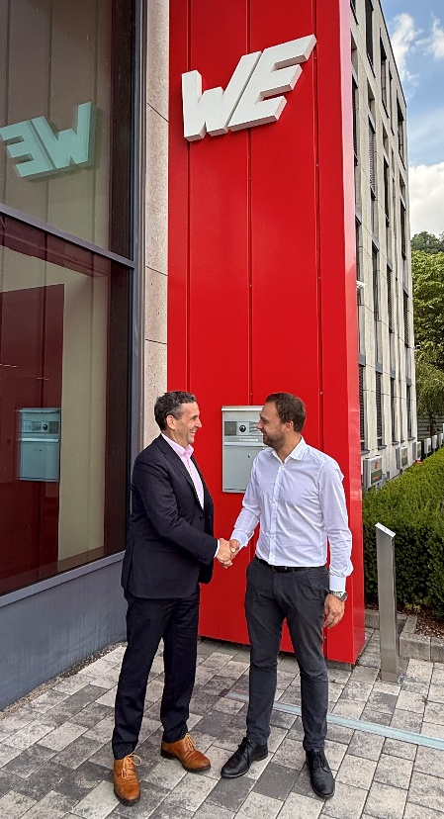
Image 1: Sealing the partnership: Daniel Jacob, CEO of STARTEAM GLOBAL and Manuel Mairhofer, Member of the Management Board of Würth Elektronik GmbH & Co. KG. Source: Würth Elektronik GmbH & Co. KG Circuit Board Technology

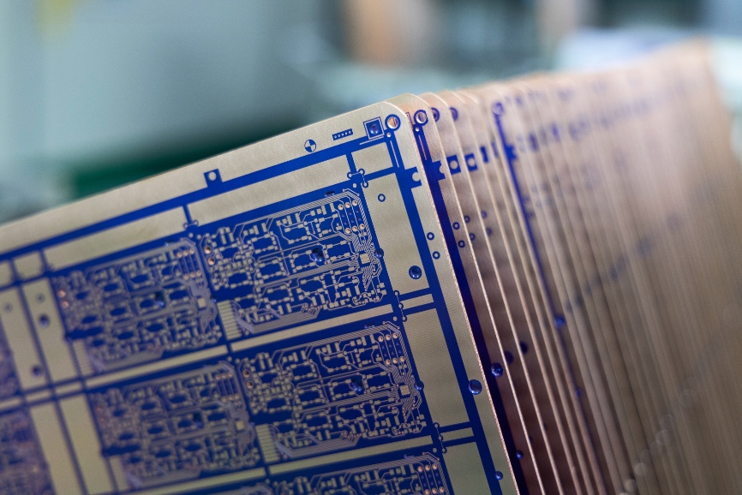
Image 2: Global shortages of printed circuit board base materials continue to impact the industry. Source: STARTEAM GLOBAL

About Würth Elektronik Circuit Board Technology
Founded in 1971, Würth Elektronik Circuit Board Technology is today one of Europe's leading PCB manufacturers, serving 4,000 customers worldwide with both domestic and international sales teams, and generating annual revenues in the triple-digit million-euro range.
Production takes place at German sites as well as through qualified partners in Asia. From basic to high-end technologies, Würth Elektronik Circuit Board Technology meets customer-specific requirements from prototypes and samples to medium and large-scale production runs. With the development of innovative product technologies, the company positions itself as a market pioneer.
Experts from the most diverse divisions provide intensive consultation and support, from the initial idea to the finished product and beyond. Würth Elektronik Circuit Board Technology sees itself as a reliable partner for both individual entrepreneurs and large corporations. The comprehensive portfolio is rounded off by an online shop, where PCBs can be ordered around the clock.

Würth Elektronik. More than you expect!

More information at https://www.we-online.com/pcb

Social Media:
https://www.we-online.com/youtube
https://www.linkedin.com/company/wuerth-elektronik-group
https://www.instagram.com/we_group/

About STARTEAM GLOBAL
Founded in Germany in 1988, STARTEAM GLOBAL is a PCB manufacturer with more than 35 years of experience serving the automotive, industrial, power solutions, energy and lighting, consumer, and medical sectors. STARTEAM is committed to delivering high-quality, reliable solutions that meet stringent safety and performance standards.
With manufacturing facilities and key offices across Europe and Asia, STARTEAM supports customers throughout the entire product lifecycle, from prototyping to mass production. This includes specialised prototyping and High Mix Low Volume (HMLV) manufacturing at Flero STARTEAM (FST) in Italy, alongside scalable production through Jiangyou STARTEAM (JST) in China and Prachinburi STARTEAM (PST) in Thailand, ensuring flexibility, continuity, and a seamless path to volume manufacturing.
Through its customer-centric approach, comprehensive portfolio of PCB technologies and services, and global footprint, STARTEAM creates long-term value for customers, partners, and stakeholders while advancing digitalisation and sustainable business practices.

Learn more at:
Website: https://starteam.global/
LinkedIn: https://www.linkedin.com/company/starteamglobal/

