PRESS RELEASE
Würth Elektronik offers UV-C-LED
Disinfecting with ultraviolet light
Waldenburg, 10 November 2021 – Würth Elektronik offers UV LEDs with emission wavelength of 275nm. This wavelength kills germs, by destroying the RNA structure of Viruses and Bacteria. Therefore, those type of LEDs are suitable for disinfection in areas where chemical components are not suitable to use. This can be devices for germicide cleaning of different surfaces, or also for air and water disinfection. Because of its compact size, lower driving voltage, short switching time and robustness, they are the preferred choice to the standard UV-C tubes. Würth Elektronik eiSos offers with the UV-C-LEDs one more technical solution for the growing needs of disinfection systems.
“Our LEDs are built to maximize the efficiency output. We can achieve this by better light extraction, due to highly transparent quartz glass. In addition, low thermal resistance ceramic substrate to reduce heating effects in the chip and increase lifetime. Finally, we use gold plating, for better soldering and contact surfaces” says Zhelio Andreev, Product Developer at Würth Elektronik eiSos. “The application areas have bright portfolio, from the medical hygiene, and water and air purification, up to food and surface sterilization. We are looking forward to help our customers in their projects, and offer our technical service and support.”
As a benefit for the developer, Würth Elektronik eiSos offers the Ray files for all UV-C products. With their help, optical simulations can be done easier, and shorten the development time for the application.
Further information is available in the Application Note ANO008. It describes the basics of UV-C disinfection and the application of UV-C LEDs. In addition, it gives useful tips for working with UV-C light.

Available images
The following images can be downloaded from the Internet in printable quality: https://kk.htcm.de/press-releases/wuerth/

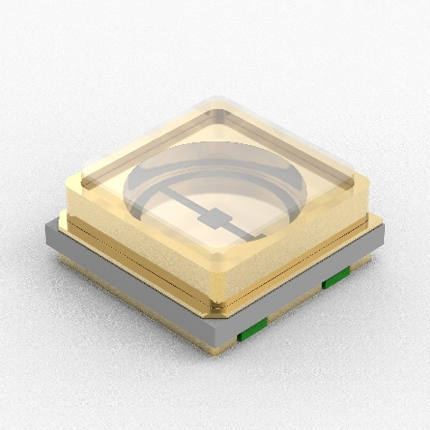
Image source: Würth Elektronik
UV-C LEDs from Würth Elektronik enable germicidal devices of small size and great effectiveness.

About the Würth Elektronik eiSos Group
Würth Elektronik eiSos Group is a manufacturer of electronic and electromechanical components for the electronics industry and a technology company that spearheads pioneering electronic solutions. Würth Elektronik eiSos is one of the largest European manufacturers of passive components and is active in 50 countries. Production sites in Europe, Asia and North America supply a growing number of customers worldwide.
The product range includes EMC components, inductors, transformers, RF components, varistors, capacitors, resistors, quartz crystals, oscillators, power modules, Wireless Power Transfer, LEDs, sensors, connectors, power supply elements, switches, push-buttons, connection technology, fuse holders and solutions for wireless data transmission.
The unrivaled service orientation of the company is characterized by the availability of all catalog components from stock without minimum order quantity, free samples and extensive support through technical sales staff and selection tools.
Würth Elektronik is part of the Würth Group, the world market leader for assembly and fastening technology. The company employs 7,300 staff and generated sales of 823 million euros in 2020.
Würth Elektronik: more than you expect!
Further information at www.we-online.com

Further information:  Würth Elektronik eiSos GmbH & Co. KG  Sarah Hurst  Max-Eyth-Strasse 1  74638 Waldenburg  Germany  Phone: +49 7942 945-5186  E-mail: sarah.hurst@we-online.de  www.we-online.com | Press contact:  HighTech communications GmbH  Brigitte Basilio  Brunhamstrasse 21  81249 Munich  Germany  Phone: +49 89 500778-20  Telefax: +49 89 500778-77  E-mail: b.basilio@htcm.de  www.htcm.de

