PRESS RELEASE

Fast and precise testing of standard oscillators, VCXOs as well as TCXO/VCTCXOs
IQD introduces Evaluation Board
Waldenburg (Germany), 2 November 2021 - The desire to be able to test oscillators quickly and easily is more than achievable using the IOSC EVBoard. The evaluation board is suitable for measuring most surface mount standard oscillators, VCXOs or TCXO/VCTCXOs. It is available from IQD, part of the Würth Elektronik eiSos Group, and a selection of distributors.
The IOSC EVBoard comes with six smaller boards that can be snapped off the main board and onto which different sized 4-pad oscillators can be soldered. The smaller board can then be soldered to the main board. The six different package sizes are 1.6 x 1.2 mm, 2.0 x 1.6 mm, 2.5 x 2.0 mm, 3.2 x 2.5 mm, 5.0 x 3.2 mm and 7.0 x 5.0 mm.
Since noise in the supply voltage can affect the frequency of the oscillator, the IOSC-EVBoard contains a regulated and filtered supply voltage. It can be freely selected between 1.8 V and 5.0 V. This allows the performance of the oscillator to be considered under ideal conditions. However, it may also be necessary to deliberately introduce noise during testing to observe the consequences. For this purpose, the IOSC EVBoard also offers the option to connect a supply voltage directly.
The Enable/Disable function can be tested by manual switching to observe the effect on current draw. In addition, there is the possibility to set this input to "high" or "low" via a digital source to measure the enable time. For products with voltage control input such as VCXOs and VCTCXOs, the board includes a potentiometer to bring the frequency tolerance and the effect of soldering back to the nominal frequency by pulling. This process can further be used to manually adjust the control voltage to simulate the effect on frequency. For sensitive products like VCTCXOs, in addition to pulling the frequency, there is the possibility to replace the applied potentiometer resistor by a fixed resistor. This leads to better stability and optimized jitter as well as phase noise. Of course, the pull input can also be fed via an external analog source.
For the output signal the IOSC-EVBoard offers three configurations. Here you can choose between a CMOS output, a clipped sine or a direct output without buffer or load. All outputs are terminated in an SMA connector.
The evaluation board is available in two options - as an unpopulated PCB supplied with the appropriate bill of materials and as a populated board for immediate use. The unpopulated version is currently available free of charge from IQD with the next 200 oscillator sample orders – It pays to be quick!

Available images
The following images can be downloaded from the Internet in printable quality: https://kk.htcm.de/press-releases/wuerth/
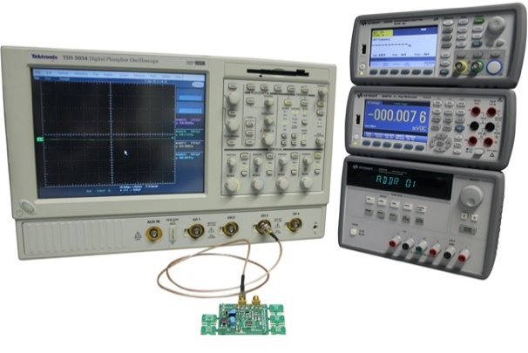Image source: IQD
IQD's Evaluation Board for Standard Oscillators

About IQD
Backed by over 40 years’ experience in the manufacture of frequency products, IQD is a recognised market leader in the frequency control market and part of the Würth Elektronik eiSos Group, one of the leading European manufacturers of passive components. With active customers in over 80 countries, IQD offers one of the most comprehensive frequency product ranges available, from low cost commercial grade product to that used in high reliability industrial and automotive applications including: Quartz Crystals, Clock Oscillators, AEC-Q200 Crystals & Oscillators, VCXOs, TCXOs, OCVCSOs & OCXOs, GPS Disciplined OCXOs, and Rubidium Oscillators.
Further info at www.iqdfrequencyproducts.com

About the Würth Elektronik eiSos Group
Würth Elektronik eiSos Group is a manufacturer of electronic and electromechanical components for the electronics industry and a technology company that spearheads pioneering electronic solutions. Würth Elektronik eiSos is one of the largest European manufacturers of passive components and is active in 50 countries. Production sites in Europe, Asia and North America supply a growing number of customers worldwide.
The product range includes EMC components, inductors, transformers, RF components, varistors, capacitors, resistors, quartz crystals, oscillators, power modules, Wireless Power Transfer, LEDs, sensors, connectors, power supply elements, switches, push-buttons, connection technology, fuse holders and solutions for wireless data transmission.
The unrivaled service orientation of the company is characterized by the availability of all catalog components from stock without minimum order quantity, free samples and extensive support through technical sales staff and selection tools.
Würth Elektronik is part of the Würth Group, the world market leader for assembly and fastening technology. The company employs 7,300 staff and generated sales of 823 million euros in 2020.
Würth Elektronik: more than you expect!
Further information at www.we-online.com

Further information:  IQD Frequency Products Ltd  Rebecca Long  Station Road  Crewkerne  Somerset  TA18 8AR  United Kingdom  Phone: +44 1460 270270  E-mail: rebecca.long@iqdfrequencyproducts.com  www.we-online.com  www.iqdfrequencyproducts.com | Press contact:  HighTech communications GmbH  Brigitte Basilio  Brunhamstrasse 21  81249 Munich  Germany  Phone: +49 89 500778-20  Telefax: +49 89 500778-77  E-mail:  b.basilio@htcm.de  www.htcm.de

