PRESS RELEASE
Würth Elektronik offers SMT spacers and contact fingers from IATF 16949 certified production
Electromechanical Components with a Stamp of Approval
Waldenburg (Germany), 27 September 2021—Würth Elektronik presents two more products qualified for the automotive industry with its WE-SCFA series contact fingers and the WA-SMSA SMT spacers. The high-quality mechanical components for PCB assembly have already proven their worth in numerous applications. Now they also have "the right paperwork" for automotive suppliers: IATF 16949 certified production. Both products excel in their solderability and are suitable for automated assembly. Design kits are also available for developers: Tray boxes with all product variants for which Würth Elektronik offers a free refill service.
WA-SMSA board-to-board connectors for SMT assembly are made of tin-plated steel and can be used as spacers to separate PCBs and/or housings by 1 mm to 15 mm. They feature strong holding forces and torques. An easily removable polyimide film serves as the pick-and-place pad. WA-SMSA is available with through via and M3 thread.
WE-SCFA contact fingers are now also available with IATF 16949 certified production. They provide an elegant way of establishing a reliable ground contact. The flexible gold-plated copper beryllium fasteners are highly resistant to mechanical and temperature-related fatigue and come in 17 different varieties.
The electromechanical products for automotive applications are available from stock in any quantities. Free samples are available on request.

Available images
The following images can be downloaded from the Internet in printable quality: https://kk.htcm.de/press-releases/wuerth/

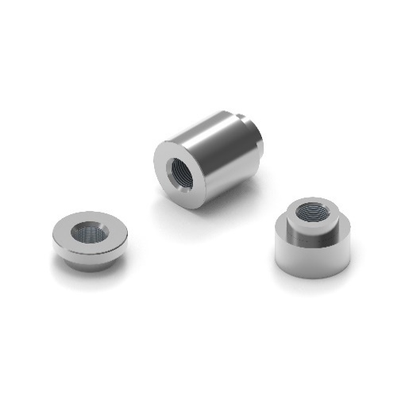  Image source: Würth Elektronik  WA-SMSA board-to-board connectors for SMT assembly | 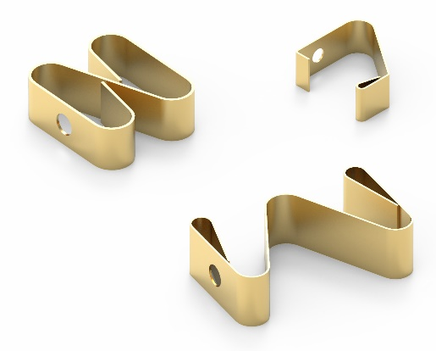  Image source: Würth Elektronik  WE-SCFA contact fingers

About the Würth Elektronik eiSos Group
Würth Elektronik eiSos Group is a manufacturer of electronic and electromechanical components for the electronics industry and a technology company that spearheads pioneering electronic solutions. Würth Elektronik eiSos is one of the largest European manufacturers of passive components and is active in 50 countries. Production sites in Europe, Asia and North America supply a growing number of customers worldwide.
The product range includes EMC components, inductors, transformers, RF components, varistors, capacitors, resistors, quartz crystals, oscillators, power modules, Wireless Power Transfer, LEDs, sensors, connectors, power supply elements, switches, push-buttons, connection technology, fuse holders and solutions for wireless data transmission.
The unrivaled service orientation of the company is characterized by the availability of all catalog components from stock without minimum order quantity, free samples and extensive support through technical sales staff and selection tools.
Würth Elektronik is part of the Würth Group, the world market leader for assembly and fastening technology. The company employs 7,300 staff and generated sales of 823 million euros in 2020.
Würth Elektronik: more than you expect!
Further information at www.we-online.com

Further information:  Würth Elektronik eiSos GmbH & Co. KG  Sarah Hurst  Max-Eyth-Strasse 1  74638 Waldenburg  Germany  Phone: +49 7942 945-5186  E-mail: sarah.hurst@we-online.de  www.we-online.com | Press contact:  HighTech communications GmbH  Brigitte Basilio  Brunhamstrasse 21  81249 Munich  Germany  Phone: +49 89 500778-20  Telefax: +49 89 500778-77  E-mail: b.basilio@htcm.de  www.htcm.de

