PRESS RELEASE

Würth Elektronik opens subsidiary in New Zealand
Milestone of success
Waldenburg (Germany), Auckland (New Zealand), November 23, 2023 – On the 24th October 2023, Wurth Electronics New Zealand Ltd., the 37th subsidiary of Würth Elektronik, officially celebrated with an opening ceremony. Ruth Poon, Managing Director Wurth Electronics New Zealand explains that Tasi Samu, Sales Area Manager has already been successfully serving and supporting customers in New Zealand since 2016. Wurth Electronics New Zealand Ltd has expanded the team headcount and will continue to build a powerful team across New Zealand.
"We are deeply grateful to our customers, because their loyalty and trust have brought us to the point where we can establish our own subsidiary," says Ruth. "The expansion strengthens us in fulfilling Würth Elektronik's claim: 'more than you expect.' We don't just want to sell components; we want our service to help our customers use them to make products that are as good and sustainable as possible." The clientele in New Zealand demonstrates their presence in World-Class electronics research and development across various markets and industries from high-tech startups to globally well-known brands. Wurth Electronics New Zealand is capable of servicing the market no matter the size of the client or intricacy of their supply chain from concept to manufacturing.
A well-known brand
The Würth Elektronik journey began over half a century ago, and since then, the company tirelessly pursued excellence in providing electronic components and technical design support worldwide. The commitment to quality, innovation, and customer satisfaction has forged a brand that resonates with engineers and businesses across the globe.
Wurth Electronics is part of the Würth Group consisting of over 400 companies. “We understand that the global market can be unforgiving, marked by fierce competition and economic downturns. However, our resilience as a fiscally solid business, as recognized by Standards Fitch and Poor having always had an A rating since the 90’s, has allowed us to weather these storms and emerge even stronger. We firmly believe in investing during market downturns, a strategy that has enabled us to gain market share swiftly, even in challenging times”, says Ruth.
Addressing the customers, Ruth Poon says: “Our dedication to innovation, quality, and customer-centric solutions remains the cornerstone of our success. We are constantly enhancing our product portfolio, expanding our technical capabilities, and investing in our global network, with new sales channels and platforms to allow us to more contactable and present such as the WEchat, available 24-5 to better serve you. We are excited about the future and are grateful for the trust and support you have placed in us over the years. We are committed to providing you with the best-in-market technical design support and electronic components. Thank you for being part of our global journey, and here’s to many more years of partnership and success.”
Prominent guests
The establishment of a new subsidiary marks an important step in international expansion for Würth Elektronik. It underlines that employees have successfully opened up a new market. The opening ceremony of Wurth Electronics New Zealand Ltd was attended by Alexander Gerfer, CTO of the Würth Elektronik eiSos Group. New Zealand is the furthest country he has travelled to. It was a pleasure for him to be present during this significant milestone and share his vision and insights.

Available images
The following images can be downloaded from the Internet in printable quality: https://kk.htcm.de/press-releases/wuerth/
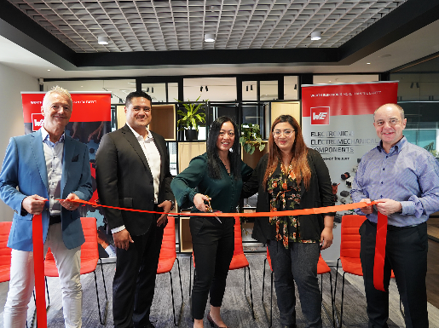Image source: Würth Elektronik  Opening the newest subsidiary: Rob Sperring, Vice President at Würth Elektronik eiSos Group, Tasi Samu, Sales Manager, Ruth Poon, General Manager and Rachel Barredo, Internal Sales and Customer Services at Wurth Electronics New Zealand Ltd. and Alexander Gerfer, CTO of the Würth Elektronik eiSos Group (from left to right). | 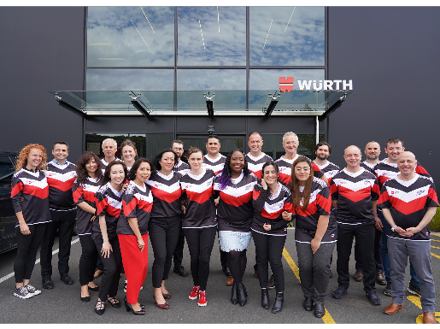  Image source: Würth Elektronik  In team colors: the staff of Wurth Electronics New Zealand Ltd. with guests

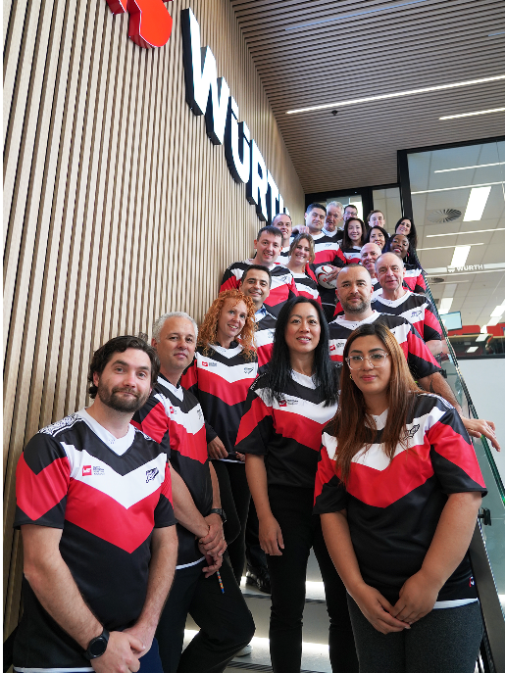
Image source: Würth Elektronik
Things are looking up for Würth Elektronik in New Zealand.

About the Würth Elektronik eiSos Group
Würth Elektronik eiSos Group is a manufacturer of electronic and electromechanical components for the electronics industry and a technology company that spearheads pioneering electronic solutions. Würth Elektronik eiSos is one of the largest European manufacturers of passive components and is active in 50 countries. Production sites in Europe, Asia and North America supply a growing number of customers worldwide.
The product range includes EMC components, inductors, transformers, RF components, varistors, capacitors, resistors, quartz crystals, oscillators, power modules, Wireless Power Transfer, LEDs, sensors, radio modules, connectors, power supply elements, switches, push-buttons, connection technology, fuse holders and solutions for wireless data transmission.
The unrivaled service orientation of the company is characterized by the availability of all catalog components from stock without minimum order quantity, free samples and extensive support through technical sales staff and selection tools.
Würth Elektronik is part of the Würth Group, the global market leader in the development, production, and sale of fastening and assembly materials, and employs 8,200 people. In 2022, the Würth Elektronik Group generated sales of 1.33 Billion Euro.
Würth Elektronik: more than you expect!
Further information at www.we-online.com

Further information:  Würth Elektronik eiSos GmbH & Co. KG  Sarah Hurst  Clarita-Bernhard-Strasse 9  81249 Munich  Germany  Phone: +49 7942 945-5186  E-mail: sarah.hurst@we-online.de  www.we-online.com | Press contact:  HighTech communications GmbH  Brigitte Basilio  Brunhamstrasse 21  81249 Munich  Germany  Phone: +49 89 500778-20  E-mail: b.basilio@htcm.de  www.htcm.de

