PRESS RELEASE

Würth Elektronik Launches New Technical Podcast
Knowledge transfer via Watts Up Podcast
Watertown (USA), 21 October 2021 –For over a decade, Würth Elektronik has been broadcasting educational materials through video services with their WEbinar program. Now, these online presentations, along with numerous Application Notes, blogs, interviews, and more are being offered through the new Würth Elektronik Watts Up Podcast.
The Watts Up Podcast is distributed weekly by multiple audio platforms including iTunes, Google Podcasts, Spotify, and more.
Amelia Thompson, Customer Outreach Analyst with Würth Elektronik, is the producer, writer, and voice of the Watts Up Podcast. Thompson says, “We have witnessed huge growth in our educational presence over the last two years through our monthly webinars. Following trend, it just makes sense to offer our knowledge through an audio layout of a podcast. Because electronics are visual, we are still able to attach pictures in our platform so the listeners can view them later.”
Since the launch in June 2021, the podcast has been downloaded by hundreds of listeners, and has covered topics such as wireless power transfer, industrial IoT, transformer design, and EMC circuitry.
“The support has been outstanding. Our customers and partners enjoy learning about our services and products, especially when we dive deeper into the technical portion. I look forward to bringing in even more education in the coming weeks,” said Thompson.
Listen to the Würth Elektronik Watts Up Podcast online at www.we-online.com/podcast.

Available images
The following images can be downloaded from the Internet in printable quality: https://kk.htcm.de/press-releases/wuerth/
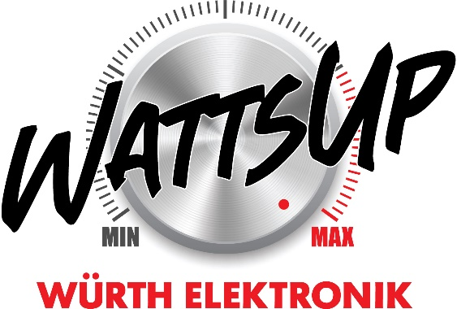
Image source: Wurth Electronics
Online presentations, Application Notes, blogs, interviews, and more are being offered through the new Würth Elektronik Watts Up Podcast.

About the Würth Elektronik eiSos Group
Würth Elektronik eiSos Group is a manufacturer of electronic and electromechanical components for the electronics industry and a technology company that spearheads pioneering electronic solutions. Würth Elektronik eiSos is one of the largest European manufacturers of passive components and is active in 50 countries. Production sites in Europe, Asia and North America supply a growing number of customers worldwide.
The product range includes EMC components, inductors, transformers, RF components, varistors, capacitors, resistors, quartz crystals, oscillators, power modules, Wireless Power Transfer, LEDs, sensors, connectors, power supply elements, switches, push-buttons, connection technology, fuse holders and solutions for wireless data transmission.
The unrivaled service orientation of the company is characterized by the availability of all catalog components from stock without minimum order quantity, free samples and extensive support through technical sales staff and selection tools.
Würth Elektronik is part of the Würth Group, the world market leader for assembly and fastening technology. The company employs 7,300 staff and generated sales of 823 million euros in 2020.
Würth Elektronik: more than you expect!
Further information at www.we-online.com

Further information:  Wurth Electronics Midcom, Inc.  Lindsey Esche  121 Airport Drive  PO Box 1330  Watertown, SD 57201 USA  Phone: +1 605 886 4385  Toll-free (in the U.S.):  Phone: +1 800 643 2661  E-mail: lindsey.esche@we-online.com  www.we-online.com | Press contact:  HighTech communications GmbH  Brigitte Basilio  Brunhamstrasse 21  81249 Munich  Germany  Phone: +49 89 500778-20  Fax: +49 89 500778-77  E-mail: b.basilio@htcm.de  www.htcm.de

