PRESS RELEASE
IQRB-2 rubidium oscillator handbook available now summarising key test data

Update on IQD’s High Performance Rubidium Oscillator IQRB-2
Waldenburg (Germany), September 1, 2021 – IQD—a Würth Elektronik eiSos Group company— is pleased to announce completion of its extended rubidium portfolio with the comprehensive IQRB-2 rubidium oscillator handbook, summarising tests undertaken: from temperature stability and short-term stability to supply pushing and more.
The IQRB-2 fills the gap between the IQRB-1 and the IQRB-3; the IQRB-1 delivers a superb price performance ratio, whereas the IQRB-3 offers an exceptional phase noise performance paired with a 1 PPS synchronization. The IQRB-2 offers a superb phase noise close to the IQRB-3 performance: a close in phase noise of -108 dBc/Hz @ 1 Hz and a noise floor of -158 dBc/Hz @ 10 kHz and below. Although it does not offer a 1 PPS synchronisation, it is available at a more competitive price vs. the IQRB-3. With a short term stability of 0.0075 ppb @ Tau = 100 s and an aging performance of a maximum of 0.05 ppb per month, the IQRB-2 is still a perfect match for various time and frequency synchronization applications.
For a convenient overview of all IQD’s rubidium products, please refer to our new rubidium flyer available on the Resources page of the IQD website.
For more information on the IQRB-2 or IQD’s rubidium portfolio in general, please visit IQD’s website at www.iqdfrequencyproducts.com. Furthermore, please contact IQD’s sales office if you have any questions or would like to get a copy of the IQRB-2 handbook.

Available images
The following images can be downloaded from the Internet in printable quality: https://kk.htcm.de/press-releases/wuerth/

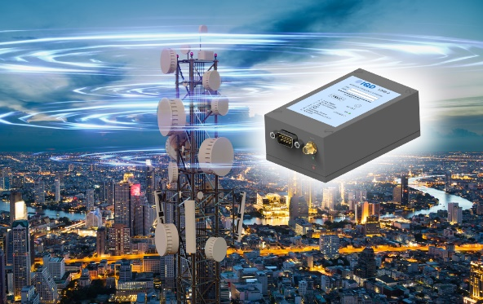
Image source: IQD
The IQRB-2, IQD’s high performance rubidium oscillator

About IQD
Backed by over 40 years’ experience in the manufacture of frequency products, IQD is a recognised market leader in the frequency control market and part of the Würth Elektronik eiSos Group, one of the leading European manufacturers of passive components. With active customers in over 80 countries, IQD offers one of the most comprehensive frequency product ranges available, from low cost commercial grade product to that used in high reliability industrial and automotive applications including: Quartz Crystals, Clock Oscillators, AEC-Q200 Crystals & Oscillators, VCXOs, TCXOs, OCVCSOs & OCXOs, GPS Disciplined OCXOs, and Rubidium Oscillators.
Further info at www.iqdfrequencyproducts.com

About the Würth Elektronik eiSos Group
Würth Elektronik eiSos Group is a manufacturer of electronic and electromechanical components for the electronics industry and a technology company that spearheads pioneering electronic solutions. Würth Elektronik eiSos is one of the largest European manufacturers of passive components and is active in 50 countries. Production sites in Europe, Asia and North America supply a growing number of customers worldwide.
The product range includes EMC components, inductors, transformers, RF components, varistors, capacitors, resistors, quartz crystals, oscillators, power modules, Wireless Power Transfer, LEDs, sensors, connectors, power supply elements, switches, push-buttons, connection technology, fuse holders and solutions for wireless data transmission.
The unrivaled service orientation of the company is characterized by the availability of all catalog components from stock without minimum order quantity, free samples and extensive support through technical sales staff and selection tools.
Würth Elektronik is part of the Würth Group, the world market leader for assembly and fastening technology. The company employs 7,300 staff and generated sales of 823 million euros in 2020.
Würth Elektronik: more than you expect!
Further information at www.we-online.com

Further information:  IQD Frequency Products Ltd  Rebecca Long  Station Road  Crewkerne  Somerset  TA18 8AR  United Kingdom  Phone: +44 1460 270270  E-mail: rebecca.long@iqdfrequencyproducts.com  www.we-online.com  www.iqdfrequencyproducts.com | Press contact:  HighTech communications GmbH  Brigitte Basilio  Brunhamstrasse 21  81249 Munich  Germany  Phone: +49 89 500778-20  Telefax: +49 89 500778-77  E-mail:  b.basilio@htcm.de  www.htcm.de

