PRESS RELEASE
Würth Elektronik at the International Vertical Farming & New Food Systems Conference and Exhibition
Influence of light for certain plant traits
Waldenburg (Germany), 8th of September 2021 - Würth Elektronik offers special LEDs and the associated biological knowledge for the targeted lighting of plants. The company maintains its own research department on Horticulture Lighting and considers itself a technological enabler in this field. Therefore, Alexander Gerfer, CTO of the Würth Elektronik eiSos Group, presented the advances at the International Vertical Farming & New Food Systems Conference and Exhibition, which took place in Munich on September 2nd and 3rd 2021.
With its own team of biologists, agronomists and collaborations with the Technical University of Munich, for example, Würth Elektronik has a special position among suppliers of LEDs. For the past six years, the manufacturer of electronic and electromechanical components has been conducting intensive research on the topic of controlling plant growth using light recipes of differently combined wavelengths. In his keynote speech, Alexander Gerfer shared his Horticulture team's findings on quality parameters in plant cultivation and their research on the associated "action spectra". Depending on the species, and in some cases even on the variety, individual light recipes are needed to enhance a certain quality parameter of the plant and, for example, to favor the formation of certain substances in the plant. Würth Elektronik supports companies in the development of corresponding lighting solutions.
For further information on Würth Elektronik's Horticulture program, please visit:
https://www.we-online.com/web/de/electronic_components/produkte_pb/produktinnovationen/we_led_it_grow.php
More information on the Vertical Farming Congress at:
https://munich2021.vertical-farming.net/

Available images
The following images can be downloaded from the Internet in printable quality: https://kk.htcm.de/press-releases/wuerth/
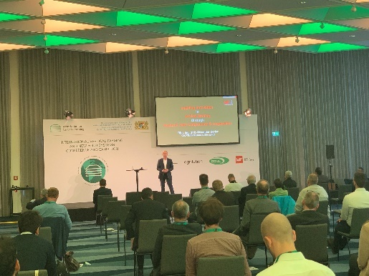Image source: Würth Elektronik  Alexander Gerfer, CTO of the Würth Elektronik eiSos Group, during his keynote speech at the International Vertical Farming & New Food Systems Conference and Exhibition. | 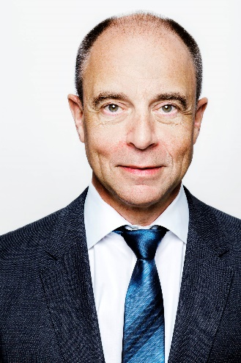  Image source: Würth Elektronik  Alexander Gerfer, CTO of the Würth Elektronik eiSos Group

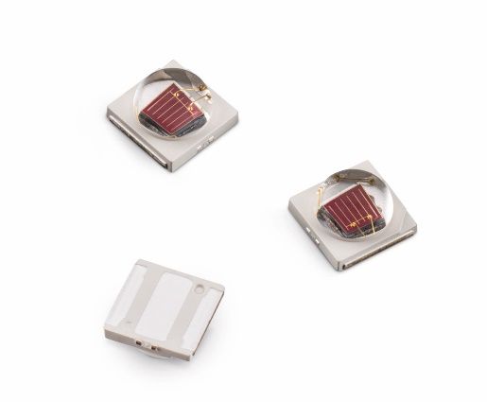  Image source: Würth Elektronik  "WL-SMDC SMT Mono-color Ceramic LED" is an LED that Würth Elektronik has developed specifically for horticultural applications. |   Image source: Würth Elektronik  This lighting unit for the individual "feeding" of plants with specific light recipes resulted from a collaborative research project with the Technical University of Munich.

About the Würth Elektronik eiSos Group
Würth Elektronik eiSos Group is a manufacturer of electronic and electromechanical components for the electronics industry and a technology company that spearheads pioneering electronic solutions. Würth Elektronik eiSos is one of the largest European manufacturers of passive components and is active in 50 countries. Production sites in Europe, Asia and North America supply a growing number of customers worldwide.
The product range includes EMC components, inductors, transformers, RF components, varistors, capacitors, resistors, quartz crystals, oscillators, power modules, Wireless Power Transfer, LEDs, sensors, connectors, power supply elements, switches, push-buttons, connection technology, fuse holders and solutions for wireless data transmission.
The unrivaled service orientation of the company is characterized by the availability of all catalog components from stock without minimum order quantity, free samples and extensive support through technical sales staff and selection tools.
Würth Elektronik is part of the Würth Group, the world market leader for assembly and fastening technology. The company employs 7,300 staff and generated sales of 823 million euros in 2020.
Würth Elektronik: more than you expect!
Further information at www.we-online.com

Further information:  Würth Elektronik eiSos GmbH & Co. KG  Sarah Hurst  Max-Eyth-Strasse 1  74638 Waldenburg  Germany  Phone: +49 7942 945-5186  E-mail: sarah.hurst@we-online.de  www.we-online.com | Press contact:  HighTech communications GmbH  Brigitte Basilio  Brunhamstrasse 21  81249 Munich  Germany  Phone: +49 89 500778-20  Telefax: +49 89 500778-77  E-mail: b.basilio@htcm.de  www.htcm.de

