PRESS RELEASE

Würth Elektronik at the GREENTECH FESTIVAL in Berlin
Technologies and start-up support for more sustainability
Waldenburg (Germany), 11 June 2021 – From June 16 to 18, 2021, the startup and innovator scene will meet in Berlin for the international GREENTECH FESTIVAL. Co-founded by sustainability entrepreneur Nico Rosberg, the event has established itself as an important networking, conference, and exhibition platform for sustainable innovations; from technologies to nutrition to clothing. Würth Elektronik is appearing as a start-up promoter and technology enabler. Agranima and Unleash Future Boats, two interesting start-ups which the manufacturer of electronic and electromechanical components maintains technology partnerships, will also be presenting themselves at the stand.The electronics experts will also be showcasing their own range of horticulture LEDs.
The GREENTECH FESTIVAL sees itself as a global platform that promotes innovative green technologies for a sustainable future. One of the festival's goals is to network start-ups with sponsors in established companies. Würth Elektronik is involved in numerous research collaborations and technology partnerships. Alexander Gerfer, CTO of the Würth Elektronik eiSos Group, explains "Start-up promotion is often narrowed down to financing in the public and political spheres. Innovation drivers such as new mobility concepts or smart agricultural technology always have electronic components. Especially in early product development, start-ups and young developers face many pitfalls in the development and transfer into producible hardware. With our know-how and as a well-connected partner, we offer real added value for creative minds. Particularly where energy-saving and sustainable innovations are concerned, we get intensively involved and, as a technology enabler, support the start-ups and their innovations so that these solutions reach the market faster and more successfully."
In-house research
The LED Horticulture Box on display at the booth, the Horticulator app for creating adapted light recipes for different plant species, and optimized LED components, are the results of research by in-house agricultural scientists in Würth Elektronik's Optoelectronics division, in cooperation with the Technical University of Munich. The growth and nutritional value of crops can be specifically controlled by light frequencies - the electronics manufacturer shares the findings from this research with solution providers in this field. The goal of these efforts is to grow crops optimally with energy-saving LEDs in closed systems close to the consumer, taking advantage of multiple crop rotations to avoid unnecessary food mileage, save water, and thus break new ground in vertical farming.
Advancing innovations
New directions in agriculture and horticulture are also the topic of partner Agranimo at the Würth Elektronik booth. The company develops systems for microclimate monitoring and water management to make agricultural production more reliable and efficient. Würth Elektronik supports the company with suitable components for prototypes, their evaluation and improvement - for example in terms of IoT radio solutions.
The field of radio technology is also central to the start-up Unleash Future Boats. The young company's first project is emission-free and autonomous high-tech catamarans for the Schlei region in Schleswig-Holstein. The planned ferries will be equipped with electric propulsion based on fuel cells and green hydrogen. The company is finding solutions that will replace fossil fuels in many areas of shipping, and allow for more efficient transportation.
"The network for the boats' communication is central to the project, where Unleash Future Boats is supported by our wireless connectivity division. We also provided the founders with helpful contacts to various companies in the Würth Group such as Würth Offshore, Würth Maritim and Würth Industrie, as well as other partner companies," says Thomas Waldmann, Start-Up & Venture Manager at Würth Elektronik eiSos. "Our Berlin branch is particularly entrusted with technology partnerships and supporting start-ups. Therefore, I am particularly pleased that we are part of the GREENTECH FESTIVALS. Here we want to celebrate innovation and change in line with the festival's motto."
More information about the event at: https://greentechfestival.com/

Available images
The following images can be downloaded from the Internet in printable quality: http://www.htcm.de/kk/wuerth
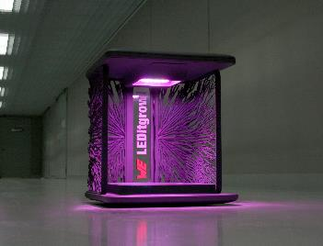
Image source: Würth Elektronik
The LED Horticulture Box will be on display at this year's GREENTECH FESTIVAL at the Würth Elektronik booth. The Horticulator app can be used to create customized lighting recipes for different plant species.

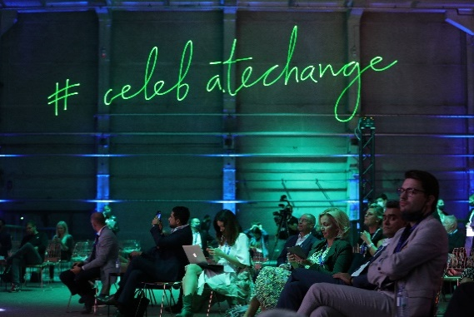Image source:  Andreas Rentz/Getty Images for Greentech Festival  General atmosphere during the GREENTECH FESTIVAL on Sept. 17, 2020 in Berlin. The GREENTECH FESTIVAL is the first festival to celebrate green technology and accelerate the change towards more sustainability. | 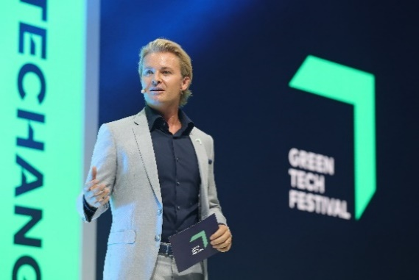Image source:  Andreas Rentz/Getty Images for Greentech Festival  Nico Rosberg speaks on stage at the last GREENTECH FESTIVAL on Sept. 16, 2020 at Kraftwerk Mitte in Berlin.

About the Würth Elektronik eiSos Group
Würth Elektronik eiSos Group is a manufacturer of electronic and electromechanical components for the electronics industry and a technology company that spearheads pioneering electronic solutions. Würth Elektronik eiSos is one of the largest European manufacturers of passive components and is active in 50 countries. Production sites in Europe, Asia and North America supply a growing number of customers worldwide.
The product range includes EMC components, inductors, transformers, RF components, varistors, capacitors, resistors, quartz crystals, oscillators, power modules, Wireless Power Transfer, LEDs, sensors, connectors, power supply elements, switches, push-buttons, connection technology, fuse holders and solutions for wireless data transmission.
The unrivaled service orientation of the company is characterized by the availability of all catalog components from stock without minimum order quantity, free samples and extensive support through technical sales staff and selection tools.
Through its technology partnership with the Audi Sport ABT Schaeffler Formula E Team and its support for the Formula Student racing series, the company demonstrates its innovative strength in eMobility
(www.we-speed-up-the-future.com).
Würth Elektronik is part of the Würth Group, the world market leader for assembly and fastening technology. The company employs 7,300 staff and generated sales of 823 million euros in 2020.
Würth Elektronik: more than you expect!
Further information at www.we-online.com

Further information:  Würth Elektronik eiSos GmbH & Co. KG  Sarah Hurst  Max-Eyth-Strasse 1  74638 Waldenburg  Germany  Phone: +49 7942 945-5186  E-mail: sarah.hurst@we-online.de  www.we-online.de | Press contact:  HighTech communications GmbH  Brigitte Basilio  Brunhamstrasse 21  81249 Munich  Germany  Phone: +49 89 500778-20  Telefax: +49 89 500778-77  E-mail: b.basilio@htcm.de  www.htcm.de

