PRESS RELEASE
Würth Elektronik extends its REDCUBE series with SMT WP-SMRA with screw threads
Right Angled Connector for Important USB Application
Waldenburg (Germany), 28 October 2021—Würth Elektronik now offers new WP-SMRA Surface mount solderable wire-to-board and board-to-board connections for 90° assembly on front panels, housings, PCBs or cable connections. WP-SMRAs are high-current contacts mainly intended for automated assembly within the REDCUBE series. The version with M2 screw thread is aimed towards a special application: Combined with Würth Elektronik's type-C USB jacks, it accepts the screw-lock USB connectors used and valued for their more reliable connection in many industrial applications.
Connectors reliably secured with screws against inadvertent disconnection are making a comeback in industrial applications with the USB type-C connector. The M2 version of the WP-SMRA SMT-mountable connector from Würth Elektronik offers developers an easy-to-implement solution along with a reference design.
WP-SMRA is now available from stock without a minimum order quantity. Würth Elektronik provides developers free samples on request.

Available images
The following images can be downloaded from the Internet in printable quality: https://kk.htcm.de/press-releases/wuerth/
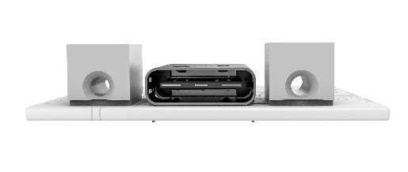  Image source: Würth Elektronik  Using two WP-SMRA and one USB-C for dual screw configuration. | 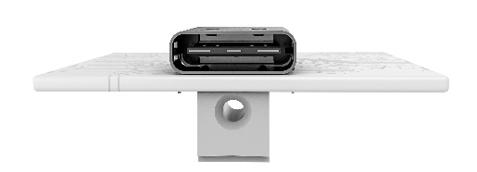  Image source: Würth Elektronik  Using one WP-SMRA and one USB-C for single screw configuration. WP-SMRA are available for PCBs of 1.0 mm and 1.6 mm thickness.

About the Würth Elektronik eiSos Group
Würth Elektronik eiSos Group is a manufacturer of electronic and electromechanical components for the electronics industry and a technology company that spearheads pioneering electronic solutions. Würth Elektronik eiSos is one of the largest European manufacturers of passive components and is active in 50 countries. Production sites in Europe, Asia and North America supply a growing number of customers worldwide.
The product range includes EMC components, inductors, transformers, RF components, varistors, capacitors, resistors, quartz crystals, oscillators, power modules, Wireless Power Transfer, LEDs, sensors, connectors, power supply elements, switches, push-buttons, connection technology, fuse holders and solutions for wireless data transmission.
The unrivaled service orientation of the company is characterized by the availability of all catalog components from stock without minimum order quantity, free samples and extensive support through technical sales staff and selection tools.
Würth Elektronik is part of the Würth Group, the world market leader for assembly and fastening technology. The company employs 7,300 staff and generated sales of 823 million euros in 2020.
Würth Elektronik: more than you expect!
Further information at www.we-online.com

Further information:  Würth Elektronik eiSos GmbH & Co. KG  Sarah Hurst  Max-Eyth-Strasse 1  74638 Waldenburg  Germany  Phone: +49 7942 945-5186  E-mail: sarah.hurst@we-online.de  www.we-online.com | Press contact:  HighTech communications GmbH  Brigitte Basilio  Brunhamstrasse 21  81249 Munich  Germany  Phone: +49 89 500778-20  Telefax: +49 89 500778-77  E-mail: b.basilio@htcm.de  www.htcm.de

