PRESS RELEASE

Würth Elektronik again at the top in company comparison study
A Good Employer for Women
Waldenburg (Germany), 11 November 2021 – Würth Elektronik eiSos is once again performing well in the Brigitte employer study. With an overall score of 4 out of a possible 5 points, the manufacturer of electronic and electromechanical components is among the leaders of the 292 companies taking part. The Germany-wide study "The best companies for women" by Brigitte magazine and the employer branding agency Territory Embrace, has evaluated how the companies perform on the following topics: work-life balance, work flexibility, career development measures, the importance of transparency and equality, and the proportion of women in management positions.
"The study helps us identify potential for further development, such as getting more women into management positions. We are proud of the good results. We were particularly pleased with the positive development in the area of 'work flexibility'. The possibility of being able to work from home and at flexible times has been available in our company for a long time, but we have all learned a lot during Corona and now implement it more actively than before," says Tanja Hochschild, Managing Director at Würth Elektronik eiSos. Hochschild is one of the initiators of the equal opportunities initiative "WoMen - WE lead together". Its guiding principle is that employees of all genders should work together at all management levels to lead Würth Elektronik successfully into the future.
Brigitte magazine asks
The questionnaire for the study "The Best Companies for Women" was co-developed by five renowned experts, the advisory board of the Brigitte Employer Study 2021: Supervisory Board member and Advisor Janina Kugel, economist Prof. Dr. Katharina Wrohlich from the German Institute for Economic Research, Fair Pay expert Henrike von Platen, Ana-Cristina Grohnert, Chairwoman of the "Charta der Vielfalt" employer initiative, and Susanne Hüsemann, Managing Director of Queb, the federal association for employer branding, personnel marketing and recruiting.

Available images
The following images can be downloaded from the Internet in printable quality: https://kk.htcm.de/press-releases/wuerth/
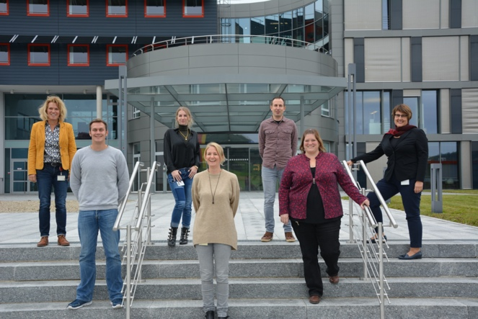Image source: Würth Elektronik
Colleagues from very different areas and hierarchical levels are shaping Würth Elektronik as part of the "WoMen - WE lead together" initiative and are very pleased to have received the award from the Brigitte study.

About the Würth Elektronik eiSos Group
Würth Elektronik eiSos Group is a manufacturer of electronic and electromechanical components for the electronics industry and a technology company that spearheads pioneering electronic solutions. Würth Elektronik eiSos is one of the largest European manufacturers of passive components and is active in 50 countries. Production sites in Europe, Asia and North America supply a growing number of customers worldwide.
The product range includes EMC components, inductors, transformers, RF components, varistors, capacitors, resistors, quartz crystals, oscillators, power modules, Wireless Power Transfer, LEDs, sensors, connectors, power supply elements, switches, push-buttons, connection technology, fuse holders and solutions for wireless data transmission.
The unrivaled service orientation of the company is characterized by the availability of all catalog components from stock without minimum order quantity, free samples and extensive support through technical sales staff and selection tools.
Würth Elektronik is part of the Würth Group, the world market leader for assembly and fastening technology. The company employs 7,300 staff and generated sales of 823 million euros in 2020.
Würth Elektronik: more than you expect!
Further information at www.we-online.com

Further information:  Würth Elektronik eiSos GmbH & Co. KG  Sarah Hurst  Max-Eyth-Strasse 1  74638 Waldenburg  Germany  Phone: +49 7942 945-5186  E-mail: sarah.hurst@we-online.de  www.we-online.com | Press contact:  HighTech communications GmbH  Brigitte Basilio  Brunhamstrasse 21  81249 Munich  Germany  Phone: +49 89 500778-20  Telefax: +49 89 500778-77  E-mail: b.basilio@htcm.de  www.htcm.de

