PRESS RELEASE
Würth Elektronik published its Wireless Connectivity & Sensors Product Guide
Radio Modules, Sensors and Tips for the IIoT
Waldenburg (Germany), July 21, 2022—The Wireless Connectivity & Sensors Division at Würth Elektronik wanted to publish more than just a catalog and now presents a "Product Guide". Its 200 pages offer a wealth of information about the products and the technologies behind them for application development. The Product Guide can be ordered at we-online.com/order-catalog.
The Wireless Connectivity & Sensors Product Guide mainly serves to make it easier for customers to select the right products for them by providing overviews, schematics and graphics on the technologies. Würth Elektronik's broad portfolio of radio modules with various common but also proprietary radio technologies forms the basis for new Internet-of-Things (IoT) applications. Equipping temperature, humidity, pressure or vibration sensors with minute power-saving radio modules is an important aspect of intelligent solutions. As adding "smart" IoT features to its own products allows many possibilities to be offered, Würth Elektronik provides numerous examples and solution strategies in the Product Guide for Smart Factory, Smart Industry, Smart Home, Smart Building and other application areas.
"We explain the products and the technologies used and strive to provide ideas on how sensor technology and networking open up new options. Of course, we also provide our customers with advice and support—through to design-in assistance. This is also what we understand as 'more than you expect'," says Markus Eberle, Marketing Manager at Würth Elektronik eiSos.

Available images
The following images can be downloaded from the Internet in printable quality: https://kk.htcm.de/press-releases/wuerth/

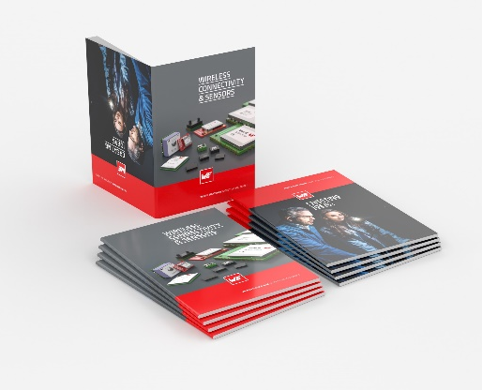
Image source: Würth Elektronik
Wireless Connectivity & Sensors Product Guide

About the Würth Elektronik eiSos Group
Würth Elektronik eiSos Group is a manufacturer of electronic and electromechanical components for the electronics industry and a technology company that spearheads pioneering electronic solutions. Würth Elektronik eiSos is one of the largest European manufacturers of passive components and is active in 50 countries. Production sites in Europe, Asia and North America supply a growing number of customers worldwide.
The product range includes EMC components, inductors, transformers, RF components, varistors, capacitors, resistors, quartz crystals, oscillators, power modules, Wireless Power Transfer, LEDs, sensors, connectors, power supply elements, switches, push-buttons, connection technology, fuse holders and solutions for wireless data transmission.
The unrivaled service orientation of the company is characterized by the availability of all catalog components from stock without minimum order quantity, free samples and extensive support through technical sales staff and selection tools.
Würth Elektronik is part of the Würth Group, the world market leader for assembly and fastening technology. The company employs 8,000 staff and generated sales of 1.09 Billion Euro in 2021.
Würth Elektronik: more than you expect!
Further information at www.we-online.com

Further information:  Würth Elektronik eiSos GmbH & Co. KG  Sarah Hurst  Max-Eyth-Strasse 1  74638 Waldenburg  Germany  Phone: +49 7942 945-5186  E-mail: sarah.hurst@we-online.de  www.we-online.com | Press contact:  HighTech communications GmbH  Brigitte Basilio  Brunhamstrasse 21  81249 Munich  Germany  Phone: +49 89 500778-20  Telefax: +49 89 500778-77  E-mail: b.basilio@htcm.de  www.htcm.de

