PRESS RELEASE

Würth Elektronik offers WE-CAR-TEC snap ferrites
Now also for the Automotive Industry
Waldenburg (Germany), November 22, 2022 – Snap ferrites have helped establish Würth Elektronik's renown as an EMC specialist. Now the manufacturer is launching another line of retrofittable interference suppression solutions with AEC-Q200 qualification, as required for the automotive industry. The WE-CAR-TEC series snap ferrites feature a NiZn core material. WE-CAR-TEC ferrites suppress electromagnetic interference in the frequency range from 1 MHz to 1 GHz.
The internal security locking system prevents unauthorized removal from the cable. Thanks to the “WE-STAR-KEY” key technology, the ferrite is reusable making it ideally suited for test and measuring purposes in the EMC lab. Each packaging unit comes with a “WE-STAR-KEY” to open the snap ferrites. WE-CAR-TEC is available in four different sizes for cable diameters from 3.5 mm to 8.5 mm. The plastic housing is UL94-V0 classified; the operating temperature ranges from -50°C to +105°C.
WE-CAR-TEC is available from stock, free samples are available.

Available images
The following images can be downloaded from the Internet in printable quality: https://kk.htcm.de/press-releases/wuerth/
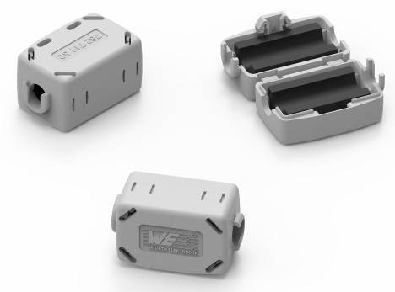
Interference suppression in the frequency range from 1 MHz to 1 GHz with the WE-CAR-TEC snap ferrites from Würth Elektronik – AEC-Q200-qualified for the automotive industry
Image source: Würth Elektronik

About the Würth Elektronik eiSos Group
Würth Elektronik eiSos Group is a manufacturer of electronic and electromechanical components for the electronics industry and a technology company that spearheads pioneering electronic solutions. Würth Elektronik eiSos is one of the largest European manufacturers of passive components and is active in 50 countries. Production sites in Europe, Asia and North America supply a growing number of customers worldwide.
The product range includes EMC components, inductors, transformers, RF components, varistors, capacitors, resistors, quartz crystals, oscillators, power modules, Wireless Power Transfer, LEDs, sensors, connectors, power supply elements, switches, push-buttons, connection technology, fuse holders and solutions for wireless data transmission.
The unrivaled service orientation of the company is characterized by the availability of all catalog components from stock without minimum order quantity, free samples and extensive support through technical sales staff and selection tools.
Würth Elektronik is part of the Würth Group, the world market leader for assembly and fastening technology. The company employs 8,000 staff and generated sales of 1.09 Billion Euro in 2021.
Würth Elektronik: more than you expect!
Further information at www.we-online.com

Further information:  Würth Elektronik eiSos GmbH & Co. KG  Sarah Hurst  Max-Eyth-Strasse 1  74638 Waldenburg  Germany  Phone: +49 7942 945-5186  E-mail: sarah.hurst@we-online.de  www.we-online.com | Press contact:  HighTech communications GmbH  Brigitte Basilio  Brunhamstrasse 21  81249 Munich  Germany  Phone: +49 89 500778-20  Telefax: +49 89 500778-77  E-mail: b.basilio@htcm.de  www.htcm.de

