PRESS RELEASE

Würth Elektronik introduces its USB 3.1 TYPE-C High-Rise SMT connectors
24 Perfect Contacts for USB Applications
Waldenburg (Germany), October 11, 2023 – Würth Elektronik is expanding its USB-C range with a 24-pin fully-configured horizontal receptacle for SMT assembly. The high-quality USB 3.1 Type-C connector features its high-rise design: It allows complete visual control of soldering thanks to its two rows each with twelve contacts. As a fully equipped Type-C connector, it is not only compatible with USB 3.2 Gen 1x2 signaling and USB Power Delivery standards, but can also be used for alternative and accessory modes. This includes transmitting analog signals via the (D+/D-) pins.
WR-COM USB 3.1 Type-C High-Rise SMT is designed for at least 10,000 mating cycles and operating temperatures from -40 to +120°C. Not only the pin contacts, but also the outer retaining pins of the shielding, are gold-plated in the contact zone to ensure the best possible connection to the PCB. The stable receptacle is suitable for all consumer and IT applications that are designed to exploit the options provided by the USB 3.2 Gen 1x2 standard in terms of data and power transfer. The latest member of the USB product family is now available from stock without a minimum order quantity, and developers can order free samples.
One-stop shop for USB solutions
Würth Elektronik offers a complete product program of connectors, EMC filters, components for ESD overvoltage protection and AC/DC to DC/DC power conversion for USB 3.1. The products are recommended in the USB Type-C reference designs from leading IC manufacturers. Components for the development of USB interfaces include, for example, pulse-stable WE-MPSB SMD ferrites for hot-plugin, high-efficiency pressed power inductors (WE-MAPI) for Vbus filters, current-compensated data line filters (WE-CNSW HF) and the WE-TVS diode for ESD line protection. As a partner for developing USB solutions, Würth Elektronik provides numerous Application Notes and reference designs.

Available images
The following images can be downloaded from the Internet in printable quality: https://kk.htcm.de/press-releases/wuerth/

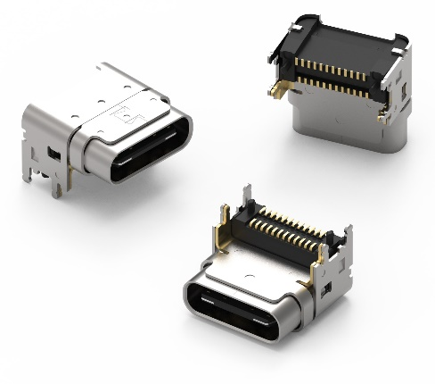
Image source: Würth Elektronik
WR-COM USB 3.1 Type-C Receptacle Horizontal High-Rise SMT

About the Würth Elektronik eiSos Group
Würth Elektronik eiSos Group is a manufacturer of electronic and electromechanical components for the electronics industry and a technology company that spearheads pioneering electronic solutions. Würth Elektronik eiSos is one of the largest European manufacturers of passive components and is active in 50 countries. Production sites in Europe, Asia and North America supply a growing number of customers worldwide.
The product range includes EMC components, inductors, transformers, RF components, varistors, capacitors, resistors, quartz crystals, oscillators, power modules, Wireless Power Transfer, LEDs, sensors, radio modules, connectors, power supply elements, switches, push-buttons, connection technology, fuse holders and solutions for wireless data transmission.
The unrivaled service orientation of the company is characterized by the availability of all catalog components from stock without minimum order quantity, free samples and extensive support through technical sales staff and selection tools.
Würth Elektronik is part of the Würth Group, the global market leader in the development, production, and sale of fastening and assembly materials, and employs 8,200 people. In 2022, the Würth Elektronik Group generated sales of 1.33 Billion Euro.
Würth Elektronik: more than you expect!
Further information at www.we-online.com

Further information:  Würth Elektronik eiSos GmbH & Co. KG  Sarah Hurst  Clarita-Bernhard-Strasse 9  81249 Munich  Germany  Phone: +49 7942 945-5186  E-mail: sarah.hurst@we-online.de  www.we-online.com | Press contact:  HighTech communications GmbH  Brigitte Basilio  Brunhamstrasse 21  81249 Munich  Germany  Phone: +49 89 500778-20  E-mail: b.basilio@htcm.de  www.htcm.de

