PRESS RELEASE
Würth Elektronik offers USB 2.0 Type C receptacles and plugs
Enjoy USB-C Power Supply and Connection Convenience
Waldenburg (Germany), September 6, 2022—Würth Elektronik offers an interesting solution for those developers who want to take advantage of the USB-C connector format for their application, but don’t need the high data rates that come with the USB 3.1 standard. Under the name WR-COM USB 2.0 type-C, Würth Elektronik presents a horizontal receptacle and vertical plug versions of the popular symmetrical connector based on the older USB standard.
The key feature of the new arrivals to Würth Elektronik's extensive USB component portfolio: Those who use the USB 2.0 version of type-C plugs can nevertheless use the higher charging current of the 3.1 standard and transfer up to 100 watts of power.
WR-COM USB 2.0 Type C is designed for longevity. The SMT-mountable components come with additional solder pads for strong mechanical fixation on the PCB. The doubled contacts are gold-plated. The durability of the connectors is at least 10,000 mating cycles. They are designed for the industrial operating temperature range of -40°C to +85°C.
The cost-effective solution for charging mobile devices via USB-C is now available from stock without a minimum order quantity. Free samples are available.

Available images
The following images can be downloaded from the Internet in printable quality: https://kk.htcm.de/press-releases/wuerth/

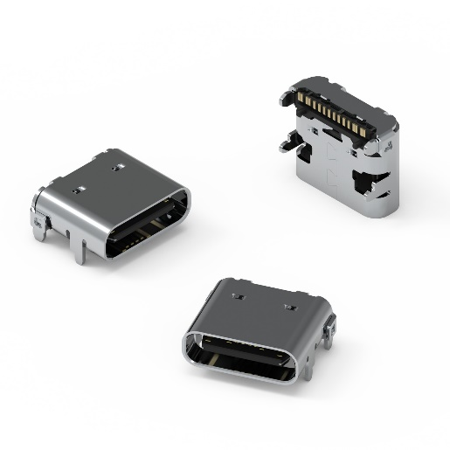  Image source: Würth Elektronik  WR-COM USB 2.0 Type C Receptacle Horizontal SMT | 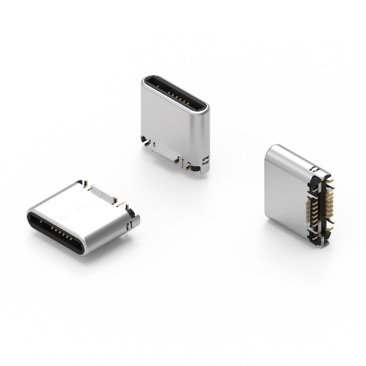  Image source: Würth Elektronik  WR-COM USB 2.0 Type C Plug Vertical SMT

About the Würth Elektronik eiSos Group
Würth Elektronik eiSos Group is a manufacturer of electronic and electromechanical components for the electronics industry and a technology company that spearheads pioneering electronic solutions. Würth Elektronik eiSos is one of the largest European manufacturers of passive components and is active in 50 countries. Production sites in Europe, Asia and North America supply a growing number of customers worldwide.
The product range includes EMC components, inductors, transformers, RF components, varistors, capacitors, resistors, quartz crystals, oscillators, power modules, Wireless Power Transfer, LEDs, sensors, connectors, power supply elements, switches, push-buttons, connection technology, fuse holders and solutions for wireless data transmission.
The unrivaled service orientation of the company is characterized by the availability of all catalog components from stock without minimum order quantity, free samples and extensive support through technical sales staff and selection tools.
Würth Elektronik is part of the Würth Group, the world market leader for assembly and fastening technology. The company employs 8,000 staff and generated sales of 1.09 Billion Euro in 2021.
Würth Elektronik: more than you expect!
Further information at www.we-online.com

Further information:  Würth Elektronik eiSos GmbH & Co. KG  Sarah Hurst  Max-Eyth-Strasse 1  74638 Waldenburg  Germany  Phone: +49 7942 945-5186  E-mail: sarah.hurst@we-online.de  www.we-online.com | Press contact:  HighTech communications GmbH  Brigitte Basilio  Brunhamstrasse 21  81249 Munich  Germany  Phone: +49 89 500778-20  Telefax: +49 89 500778-77  E-mail: b.basilio@htcm.de  www.htcm.de

