PRESS RELEASE

Würth Elektronik presents current-compensated data line filter WE-CNSA
Interference-free data transmission in the automobile
Waldenburg (Germany), October 13, 2022— Würth Elektronik presents WE-CNSA, an AEC-Q200 qualified common mode choke for automotive applications. The SMT component, which is only two millimeters long and 1.2 millimeter high, is available in six versions with different inductance and impedance values.
WE-CNSA provides signal integrity in many applications such as automotive infotainment and communications via FlexRay, IEEE 1394 (Firewire), LVDS or USB 2.0 and 3.0. The 0805 device features low resistance and a bifilar winding, meaning the two data lines run in parallel around the core. This symmetry improves the suppression of common-mode noise that can couple into data lines.
EMC specialist Würth Elektronik is now offering the filter, which achieves high common-mode noise suppression at high frequencies, from stock and is providing free samples to developers.

Available images
The following images can be downloaded from the Internet in printable quality: https://kk.htcm.de/press-releases/wuerth/
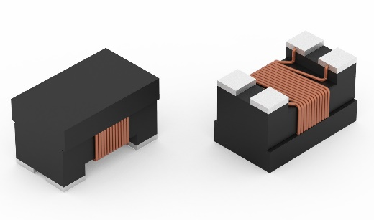Image source: Würth Elektronik
The AEC-Q200 qualified current-compensated data line filter WE-CNSA from Würth Elektronik

About the Würth Elektronik eiSos Group
Würth Elektronik eiSos Group is a manufacturer of electronic and electromechanical components for the electronics industry and a technology company that spearheads pioneering electronic solutions. Würth Elektronik eiSos is one of the largest European manufacturers of passive components and is active in 50 countries. Production sites in Europe, Asia and North America supply a growing number of customers worldwide.
The product range includes EMC components, inductors, transformers, RF components, varistors, capacitors, resistors, quartz crystals, oscillators, power modules, Wireless Power Transfer, LEDs, sensors, connectors, power supply elements, switches, push-buttons, connection technology, fuse holders and solutions for wireless data transmission.
The unrivaled service orientation of the company is characterized by the availability of all catalog components from stock without minimum order quantity, free samples and extensive support through technical sales staff and selection tools.
Würth Elektronik is part of the Würth Group, the world market leader for assembly and fastening technology. The company employs 8,000 staff and generated sales of 1.09 Billion Euro in 2021.
Würth Elektronik: more than you expect!
Further information at www.we-online.com

Further information:  Würth Elektronik eiSos GmbH & Co. KG  Sarah Hurst  Max-Eyth-Strasse 1  74638 Waldenburg  Germany  Phone: +49 7942 945-5186  E-mail: sarah.hurst@we-online.de  www.we-online.com | Press contact:  HighTech communications GmbH  Brigitte Basilio  Brunhamstrasse 21  81249 Munich  Germany  Phone: +49 89 500778-20  Telefax: +49 89 500778-77  E-mail: b.basilio@htcm.de  www.htcm.de

