PRESS RELEASE

Würth Elektronik eiSos sets up part of the electronics laboratory in Teknopark Istanbul
Training and support for technology developers
Waldenburg (Germany), November 11, 2022—Würth Elektronik eiSos in Turkey is working in cooperation with Cube Incubation in equipping an electronics workshop in Teknopark Istanbul. At the "Incubation Center for Deep Tech Entrepreneurs," of the non-profit organization Cube Incubation, more than 450 entrepreneurs and 14 universities are being supported in the development of new technologies and products. Würth Elektronik eiSos, a manufacturer of electronic and electromechanical components, has been involved as a partner to developers and innovative start-ups for some time. By providing components, laboratory equipment, and expertise, innovative developments accelerate.
The opening of the Incubation Center's electronics workshop on October 19, 2022 with Ahmet Çakır, General Manager of Würth Elektronik eiSos in Turkey, was followed by a presentation of the facility. Among others, Thomas Schrott, CEO of the Würth Elektronik eiSos Group, Bilal Topçu, General Manager of Teknopark Istanbul, and Ahmet Kerim Nalbant, Manager of the Incubation Center, took part in the tour. They learned how innovative companies can receive support in electronics issues and work on prototypes in the future.
Ahmet Çakır is pleased about the cooperation. "The Incubation Center is an impressive facility and we are happy to participate in the electronics workshop of the institution with components, laboratory equipment and know-how. At Würth Elektronik eiSos in Turkey, we have already supported many university teams, and we look forward to supporting many more innovative projects and start-up companies in this cooperation with Teknopark."
As part of the event, the Würth Elektronik eiSos in Turkey team brought together representatives of important customers and start-up companies at a joint meal to cultivate contacts for future development projects at the Incubation Center.

Available images
The following images can be downloaded from the Internet in printable quality: https://kk.htcm.de/press-releases/wuerth/

Image source: Würth Elektronik  On the occasion of the opening of the electronics workshop in the "Incubation Center for Deep Tech Entrepreneurs", Thomas Schrott, CEO of the Würth Elektronik eiSos Group, signed a circuit board. | 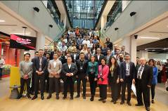  Image source: Würth Elektronik  The team from Würth Elektronik eiSos in Turkey will help solve electronics problems at the Incubation Center.

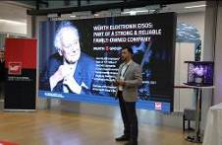Image source: Würth Elektronik  Ahmet Çakır, General Manager of Würth Elektronik eiSos in Turkey, introduces the Würth Group and Würth Elektronik to the visitors. | 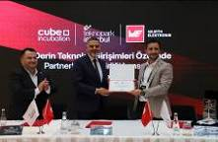  Image source: Würth Elektronik  Ahmet Çakır, General Manager of Würth Elektronik eiSos in Turkey, presents Bilal Topçu, General Manager of Teknopark Istanbul, with a certificate for the seedlings planted in the "Würth Elektronik Memorial Forest" on behalf of Teknopark Istanbul.

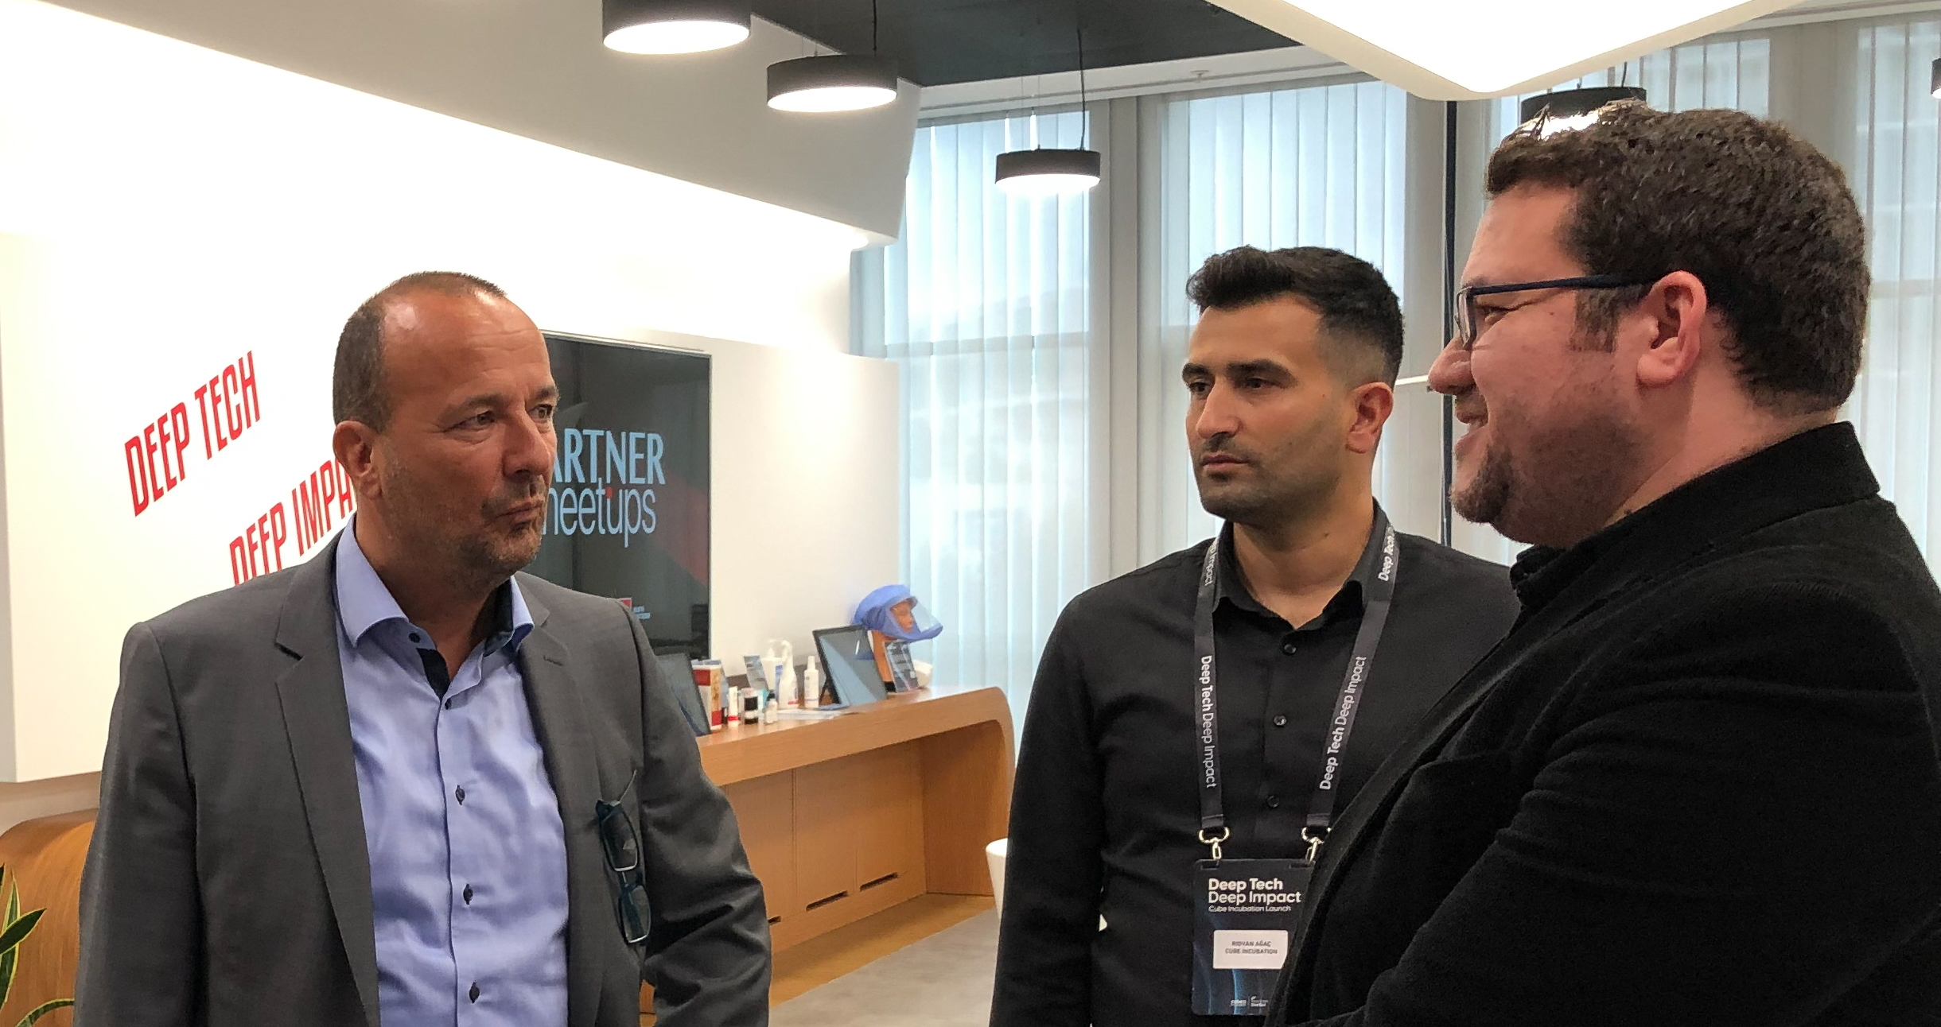
Image source: Würth Elektronik
Thomas Schrott, CEO of the Würth Elektronik eiSos Group, learned about the Incubation Center for Deep Tech Entrepreneurs

About the Würth Elektronik eiSos Group
Würth Elektronik eiSos Group is a manufacturer of electronic and electromechanical components for the electronics industry and a technology company that spearheads pioneering electronic solutions. Würth Elektronik eiSos is one of the largest European manufacturers of passive components and is active in 50 countries. Production sites in Europe, Asia and North America supply a growing number of customers worldwide.
The product range includes EMC components, inductors, transformers, RF components, varistors, capacitors, resistors, quartz crystals, oscillators, power modules, Wireless Power Transfer, LEDs, sensors, connectors, power supply elements, switches, push-buttons, connection technology, fuse holders and solutions for wireless data transmission.
The unrivaled service orientation of the company is characterized by the availability of all catalog components from stock without minimum order quantity, free samples and extensive support through technical sales staff and selection tools.
Würth Elektronik is part of the Würth Group, the world market leader for assembly and fastening technology. The company employs 8,000 staff and generated sales of 1.09 Billion Euro in 2021.
Würth Elektronik: more than you expect!
Further information at www.we-online.com

Further information:  Würth Elektronik eiSos GmbH & Co. KG  Sarah Hurst  Max-Eyth-Strasse 1  74638 Waldenburg  Germany  Phone: +49 7942 945-5186  E-mail: sarah.hurst@we-online.de  www.we-online.com | Press contact:  HighTech communications GmbH  Brigitte Basilio  Brunhamstrasse 21  81249 Munich  Germany  Phone: +49 89 500778-20  Telefax: +49 89 500778-77  E-mail: b.basilio@htcm.de  www.htcm.de

