PRESS RELEASE
Würth Elektronik introduces its WS-TASV tact switches
Extra Small, Robust and Washable
Waldenburg (Germany), July 28, 2022—Würth Elektronik introduces another high-quality switch from the series of washable tact switches. The WS-TASV Tact Switch for SMT assembly is particularly space-saving with a footprint of just 4.1 x 2.8 mm and height of 1.9 mm. Three variants are available, color-coded according to their actuating force: 200 grams (black), 300 grams (white), 400 grams (salmon). The tact switches are designed for an operating temperature range of -55°C to +125°C.
Tact switches from Würth Elektronik feature reliability and a long service life. All metallic parts of the switches are tested for corrosion resistance with a 48-hour salt spray test. Polyimide film protects the tact switch even under extreme operating conditions. High-quality snap domes made of stainless steel ensure high reliability and reduced friction—tested in full-load lifecycle.
The rated current is 50 mA and rated voltage 32 V. The service life is between 100,000 and 200,000 cycles, depending on the operation force. The initial contact resistance is 100 mΩ, and after service life testing is 2 Ω.
Würth Elektronik provides developers with free samples of the WS-TASV. The tact switch is available from stock without a minimum order quantity.

Available images
The following images can be downloaded from the Internet in printable quality: https://kk.htcm.de/press-releases/wuerth/
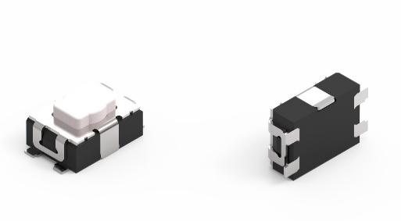
WS-TASV tact switches
Image source: Würth Elektronik

About the Würth Elektronik eiSos Group
Würth Elektronik eiSos Group is a manufacturer of electronic and electromechanical components for the electronics industry and a technology company that spearheads pioneering electronic solutions. Würth Elektronik eiSos is one of the largest European manufacturers of passive components and is active in 50 countries. Production sites in Europe, Asia and North America supply a growing number of customers worldwide.
The product range includes EMC components, inductors, transformers, RF components, varistors, capacitors, resistors, quartz crystals, oscillators, power modules, Wireless Power Transfer, LEDs, sensors, connectors, power supply elements, switches, push-buttons, connection technology, fuse holders and solutions for wireless data transmission.
The unrivaled service orientation of the company is characterized by the availability of all catalog components from stock without minimum order quantity, free samples and extensive support through technical sales staff and selection tools.
Würth Elektronik is part of the Würth Group, the world market leader for assembly and fastening technology. The company employs 8,000 staff and generated sales of 1.09 Billion Euro in 2021.
Würth Elektronik: more than you expect!
Further information at www.we-online.com

Further information:  Würth Elektronik eiSos GmbH & Co. KG  Sarah Hurst  Max-Eyth-Strasse 1  74638 Waldenburg  Germany  Phone: +49 7942 945-5186  E-mail: sarah.hurst@we-online.de  www.we-online.com | Press contact:  HighTech communications GmbH  Brigitte Basilio  Brunhamstrasse 21  81249 Munich  Germany  Phone: +49 89 500778-20  Telefax: +49 89 500778-77  E-mail: b.basilio@htcm.de  www.htcm.de

