PRESS RELEASE

Würth Elektronik Gold Partner of the European Hyperloop Week for the second time
Advancing technology - shaping the future
Waldenburg (Germany), Delft, Hilversum (Netherlands), July 26, 2022—From July 18 to 24, the European Hyperloop Week took place in Delft and Hilversum, Netherlands (https://hyperloopweek.com). Würth Elektronik was involved in many ways: as a Gold Partner, jury member and speaker at the event, as well as a long-term technology partner of several teams. Unlike the SpaceX competitions, the event launched by four student Hyperloop teams is not primarily about pod speed. Here, the focus is on sustainability, scalability and feasibility. The prize awarded by Würth Elektronik for the best "Thermal & EMC Management" went to the Hyperloop UPV Valencia team.
31 international student teams participated in the week of events, which offered plenty of variety with conferences, technical presentations, seminars, keynotes, panel discussions and design competitions. Disciplines included Mechanical Properties, Electronic System, Traction, Design, and Economy and Efficiency.
The event concluded on Sunday evening with an awards ceremony. The following teams came out on top in the above categories:
Team Hyperloop UPV: Thermal & EMC Management and the Guiding Subsystem.
Team mu-zero HYPERLOOP: Technical Aspects of Hyperloop Systems, Socioeconomic Aspects of Hyperloop Systems, Electrical Subsystem
Team Swissloop: Traction Subsystem, Mechanical Subsystem
Team Delft Hyperloop: Complete Pod
A special highlight on Thursday, July 21, was the keynote speech by Alexander Gerfer, CTO at Würth Elektronik eiSos Group, on the topic: "Are you ready for the hard road to reach your big goal? - Experience and Learnings from a CTO perspective." Among other things, it dealt with the development process using the example of temperature management in high-current applications.
Shielding, connection technology, 3D
Würth Elektronik has been supporting numerous Hyperloop teams for some time, first and foremost Swissloop Switzerland, HYPED in Edinburgh, UPV Valencia and CHF Madrid, mų-zero Hyperloop Karlsruhe, Shift Norway, KTH Stockholm and Delft Hyperloop. Jorge Victoria, Senior Product Manager EMC Shielding & Thermal Materials at Würth Elektronik eiSos, was particularly involved. He supported the teams in various issues related to heat loss and electromagnetic compatibility and was part of the jury. Other key areas of support from Würth Elektronik included performance enhancement in thermal management while saving weight in the pods through 3D printed alternative components and vibration-resistant press-fit contacts (REDcube terminals) as a connection solution in the high-current area.
"As a technology enabler, it goes without saying that we support future technologies such as Hyperloop in theory and practice," explains Gerfer. "For us, future technology means not only record-breaking journeys, but also many innovations in a wide variety of areas that, taken together, make new mobility concepts feasible in the first place - economically, sustainably and scalably."

Available images
The following images can be downloaded from the Internet in printable quality: https://kk.htcm.de/press-releases/wuerth/
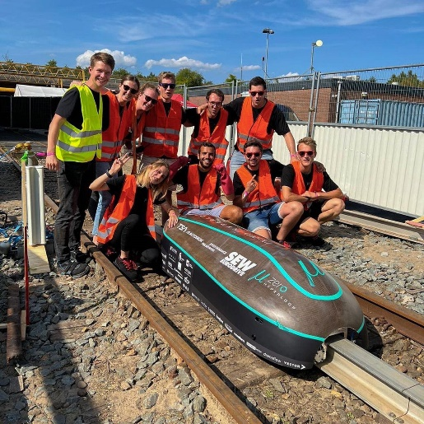  Image source: Team mųZero Hyperloop  The team mu-zero HYPERLOOP could win three categories at once. | 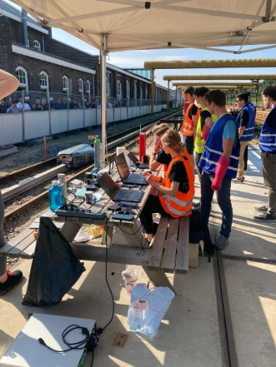  Image source: Würth Elektronik  Team mu-zero HYPERLOOP has everything under control.

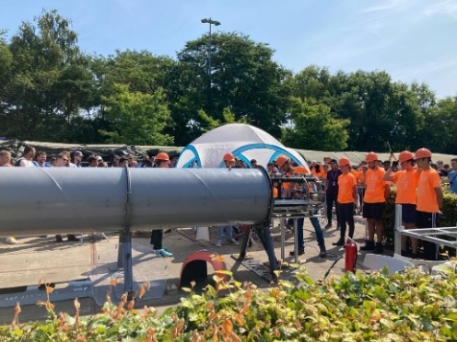 Image source: Würth Elektronik  Off into the tube - the Hyperloop principle of moving capsules in a largely airless tube was also tested again. | 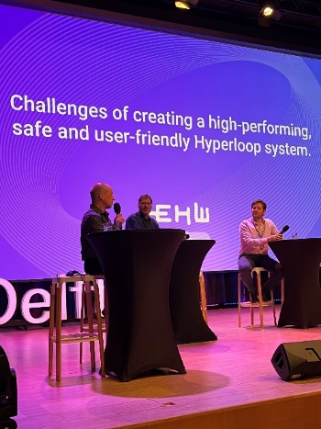  Image source: Würth Elektronik  Alexander Gerfer, CTO of the Würth Elektronik eiSos Group, (left) on the podium at the European Hyperloop Week in Delft.

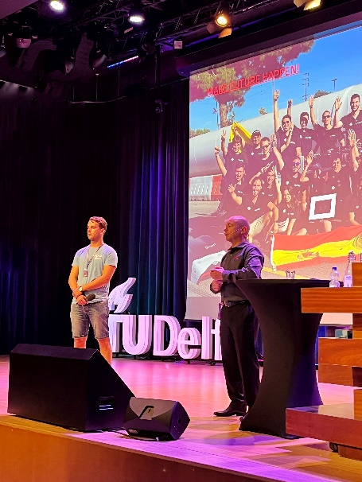 Image source: Würth Elektronik  Alexander Gerfer, CTO of the Würth Elektronik eiSos Group (right) during his presentation at the European Hyperloop Week in Delft. | 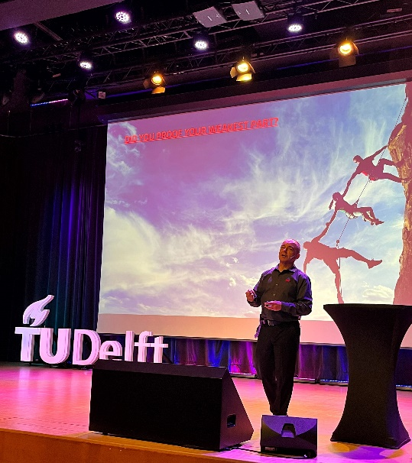  Image source: Würth Elektronik  „Are you ready for the hard road to reach your big goal? – Experience and Learnings from a CTO perspective“, was the topic of the keynote by Alexander Gerfer, CTO at the Würth Elektronik eiSos Group at the European Hyperloop Week in Delft.

About the Würth Elektronik eiSos Group
Würth Elektronik eiSos Group is a manufacturer of electronic and electromechanical components for the electronics industry and a technology company that spearheads pioneering electronic solutions. Würth Elektronik eiSos is one of the largest European manufacturers of passive components and is active in 50 countries. Production sites in Europe, Asia and North America supply a growing number of customers worldwide.
The product range includes EMC components, inductors, transformers, RF components, varistors, capacitors, resistors, quartz crystals, oscillators, power modules, Wireless Power Transfer, LEDs, sensors, connectors, power supply elements, switches, push-buttons, connection technology, fuse holders and solutions for wireless data transmission.
The unrivaled service orientation of the company is characterized by the availability of all catalog components from stock without minimum order quantity, free samples and extensive support through technical sales staff and selection tools.
Würth Elektronik is part of the Würth Group, the world market leader for assembly and fastening technology. The company employs 8,000 staff and generated sales of 1.09 Billion Euro in 2021.
Würth Elektronik: more than you expect!
Further information at www.we-online.com

Further information:  Würth Elektronik eiSos GmbH & Co. KG  Sarah Hurst  Max-Eyth-Strasse 1  74638 Waldenburg  Germany  Phone: +49 7942 945-5186  E-mail: sarah.hurst@we-online.de  www.we-online.com | Press contact:  HighTech communications GmbH  Brigitte Basilio  Brunhamstrasse 21  81249 Munich  Germany  Phone: +49 89 500778-20  Telefax: +49 89 500778-77  E-mail: b.basilio@htcm.de  www.htcm.de

