PRESS RELEASE
Würth Elektronik introduces its WE-BMS signal transformers
Reliable Battery Management
Waldenburg (Germany), August 25, 2022—With WE-BMS, Würth Elektronik presents signal transformers for battery management systems which, thanks to their galvanic isolation of 4300 V_{DC}/1 min and high operating voltage of up to 1000 V_{DC}, are ideal for use in energy storage systems, E-bikes or E-scooters. Besides the transformers, the new WE-BMS series components also include at least one common-mode choke to filter common-mode interference. Würth Elektronik's design offers far longer physical creepage than comparable products on the market yet is very compact. Low-profile component variants of 3.45 mm height are also available.
As the product code WE-BMS spells out, the transformers are absolutely optimized for battery management systems. They are primarily used to ensure reliable operation and provide information about the charging status. The individual cells of a battery pack are connected in series, as are the downstream BMS controllers. Voltage differences and electromagnetic interference may occur between series-connected components or boards. The WE-BMS transformer serves to isolate components from each other and suppress EMI. Applications include storage systems for solar installations or uninterrupted power supplies (UPS). As the WE-BMS series is AEC-Q200 qualified, it is also very well suited for E-mobility applications. WE-BMS supports serial daisy chain, isoSPI and SPI.
Free samples for electronics developers
Designed for the extended operating temperature range between -40°C and 125°C, the component is available from stock in various sizes from 7.6 x 9.5 x 5.5 mm to 15.1 x 15.4 x 3.45 mm with no minimum order quantity. Würth Elektronik provides free samples for engineers.

Available images
The following images can be downloaded from the Internet in printable quality: https://kk.htcm.de/press-releases/wuerth/
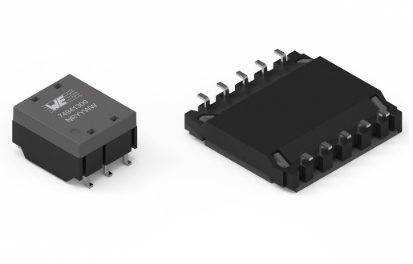Image source: Würth Elektronik
WE-BMS is a transformer optimized for battery management systems

About the Würth Elektronik eiSos Group
Würth Elektronik eiSos Group is a manufacturer of electronic and electromechanical components for the electronics industry and a technology company that spearheads pioneering electronic solutions. Würth Elektronik eiSos is one of the largest European manufacturers of passive components and is active in 50 countries. Production sites in Europe, Asia and North America supply a growing number of customers worldwide.
The product range includes EMC components, inductors, transformers, RF components, varistors, capacitors, resistors, quartz crystals, oscillators, power modules, Wireless Power Transfer, LEDs, sensors, connectors, power supply elements, switches, push-buttons, connection technology, fuse holders and solutions for wireless data transmission.
The unrivaled service orientation of the company is characterized by the availability of all catalog components from stock without minimum order quantity, free samples and extensive support through technical sales staff and selection tools.
Würth Elektronik is part of the Würth Group, the world market leader for assembly and fastening technology. The company employs 8,000 staff and generated sales of 1.09 Billion Euro in 2021.
Würth Elektronik: more than you expect!
Further information at www.we-online.com

Further information:  Würth Elektronik eiSos GmbH & Co. KG  Sarah Hurst  Max-Eyth-Strasse 1  74638 Waldenburg  Germany  Phone: +49 7942 945-5186  E-mail: sarah.hurst@we-online.de  www.we-online.com | Press contact:  HighTech communications GmbH  Brigitte Basilio  Brunhamstrasse 21  81249 Munich  Germany  Phone: +49 89 500778-20  Telefax: +49 89 500778-77  E-mail: b.basilio@htcm.de  www.htcm.de

