PRESS RELEASE
Würth Elektronik publishes its new power supply reference design
Auxiliary Power Supply for SiC MOSFETs and IGBT Gate Drivers
Waldenburg (Germany), November 3, 2022—Würth Elektronik presents technically mature circuit templates for developers in its reference designs. Release RD002 is currently available for free download: 6 W unipolar isolated auxiliary supply for SiC MOSFETs and IGBT gate drivers. It explains the setup of a 27 x 14 x 14 mm small board with adjustable output voltage.
The reference design delivers a unipolar output voltage of 15 to 20 volts at 6 watts of power and can be used in battery chargers, solar system inverters, AC motors or switch-mode power supplies with SiC MOSFETs, to name but a few.
Circuitry and layout
An isolated low-power auxiliary power supply, typically with a flyback, push-pull, or half-bridge topology, provides the gate drive voltage level and power required to turn the SiC transistor on and off, as well as galvanic isolation between the high-voltage and low-voltage sides. Isolation is necessary, not only to meet the relevant safety standards, but also to reduce electrical interference due to coupling between the primary and secondary sides of the converter and hence to enhance EMC and the stability of the gate driver control. The transformer in the auxiliary power supply (WE-750318114) performs this main task. The reference design presents the circuitry and components and shows different layout variants.
“As developers, we don't have to keep reinventing the wheel, and that includes circuit technology,” says Falco Eleazar, Application Engineer at Würth Elektronik eiSos. “Thanks to our reference designs, you save a lot of time and can be sure that the components featured are also reliably available from stock.”
Reference design RD002 is available at www.we-online.com/RD002.

Available images
The following images can be downloaded from the Internet in printable quality: https://kk.htcm.de/press-releases/wuerth/

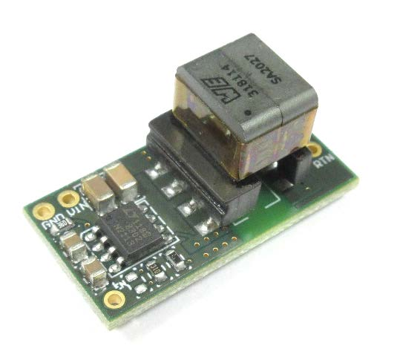
Image source: Würth Elektronik
Compact and functionally stable: Power supply according to reference design RD002 from Würth Elektronik

About the Würth Elektronik eiSos Group
Würth Elektronik eiSos Group is a manufacturer of electronic and electromechanical components for the electronics industry and a technology company that spearheads pioneering electronic solutions. Würth Elektronik eiSos is one of the largest European manufacturers of passive components and is active in 50 countries. Production sites in Europe, Asia and North America supply a growing number of customers worldwide.
The product range includes EMC components, inductors, transformers, RF components, varistors, capacitors, resistors, quartz crystals, oscillators, power modules, Wireless Power Transfer, LEDs, sensors, connectors, power supply elements, switches, push-buttons, connection technology, fuse holders and solutions for wireless data transmission.
The unrivaled service orientation of the company is characterized by the availability of all catalog components from stock without minimum order quantity, free samples and extensive support through technical sales staff and selection tools.
Würth Elektronik is part of the Würth Group, the world market leader for assembly and fastening technology. The company employs 8,000 staff and generated sales of 1.09 Billion Euro in 2021.
Würth Elektronik: more than you expect!
Further information at www.we-online.com

Further information:  Würth Elektronik eiSos GmbH & Co. KG  Sarah Hurst  Max-Eyth-Strasse 1  74638 Waldenburg  Germany  Phone: +49 7942 945-5186  E-mail: sarah.hurst@we-online.de  www.we-online.com | Press contact:  HighTech communications GmbH  Brigitte Basilio  Brunhamstrasse 21  81249 Munich  Germany  Phone: +49 89 500778-20  Telefax: +49 89 500778-77  E-mail: b.basilio@htcm.de  www.htcm.de

