PRESS RELEASE

Würth Elektronik Receives Very Positive Ratings in the Women’s Career Index
FKI-Certified: “WoMen – WE lead together”
Waldenburg (Germany), October 12, 2022—For the first time, Würth Elektronik eiSos GmbH & Co. KG has participated in the independent indexing by the Women’s Career Index (FKI). The positive results confirm the company’s concept including mixed teams at all levels and the targeted promotion of diversity and women’s careers.
Würth Elektronik has been driving an ambitious project forward for five years with the initiative “WoMen – WE lead together.” Here, women and men are to be equally represented at all management levels in the company.
Encouraging results for overall index and general conditions
Würth Elektronik was directly compared with other companies in German-speaking countries when the company was indexed by the Women’s Career Index (FKI). The FKI surveys isolated company values for women, leadership, and diversity, and examines the internal driving factors and initiatives for more women in leadership positions. The results of the certification are impressive, with an overall index of 73 points and an outstanding index score of 92 for the framework conditions, such as working hours, mission/vision, and transparency.
Economic advantages through equality
“As a company, we need to secure the brightest minds, no matter what body they sit on,” explains Tanja Hochschild, member of the management board at Würth Elektronik eiSos. “Studies show that diversity is not only a question of equity, but also brings tangible economic benefits. The result of the FKI certification is both confirmation and incentive for us. As part of the assessment, we also received many exciting ideas and suggestions of where we can focus even more in the future.”

Available images
The following images can be downloaded from the Internet in printable quality: https://kk.htcm.de/press-releases/wuerth/

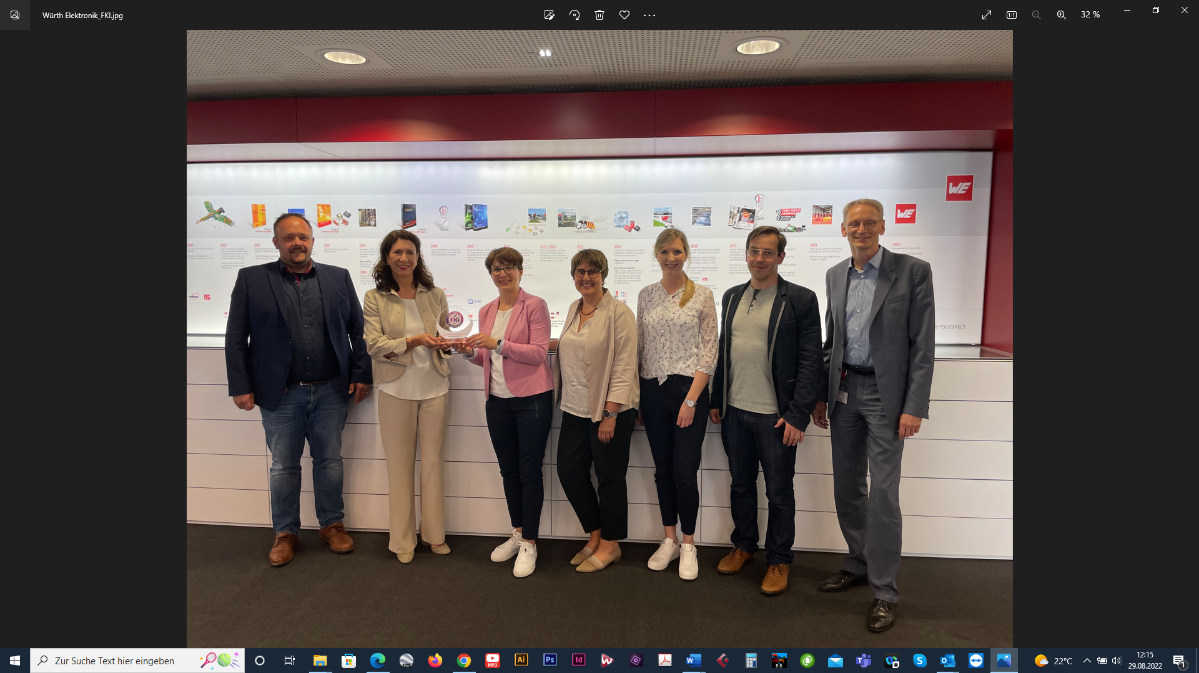Image source: Würth Elektronik
Diversity work confirmed: Barbara Lutz (2nd from left), Managing Director FKI, personally congratulates Würth Elektronik on the positive certification result.

About the Würth Elektronik eiSos Group
Würth Elektronik eiSos Group is a manufacturer of electronic and electromechanical components for the electronics industry and a technology company that spearheads pioneering electronic solutions. Würth Elektronik eiSos is one of the largest European manufacturers of passive components and is active in 50 countries. Production sites in Europe, Asia and North America supply a growing number of customers worldwide.
The product range includes EMC components, inductors, transformers, RF components, varistors, capacitors, resistors, quartz crystals, oscillators, power modules, Wireless Power Transfer, LEDs, sensors, connectors, power supply elements, switches, push-buttons, connection technology, fuse holders and solutions for wireless data transmission.
The unrivaled service orientation of the company is characterized by the availability of all catalog components from stock without minimum order quantity, free samples and extensive support through technical sales staff and selection tools.
Würth Elektronik is part of the Würth Group, the world market leader for assembly and fastening technology. The company employs 8,000 staff and generated sales of 1.09 Billion Euro in 2021.
Würth Elektronik: more than you expect!
Further information at www.we-online.com

Further information:  Würth Elektronik eiSos GmbH & Co. KG  Sarah Hurst  Max-Eyth-Strasse 1  74638 Waldenburg  Germany  Phone: +49 7942 945-5186  E-mail: sarah.hurst@we-online.de  www.we-online.com | Press contact:  HighTech communications GmbH  Brigitte Basilio  Brunhamstrasse 21  81249 Munich  Germany  Phone: +49 89 500778-20  Telefax: +49 89 500778-77  E-mail: b.basilio@htcm.de  www.htcm.de

