PRESS RELEASE
New space for innovations:
Würth Elektronik Moves Into Hightech Innovation Center in Munich

Munich (Germany), December 21, 2022 – Moving into the future: The HIC is the new innovation center of the Würth Elektronik Group of Companies. The location in Freiham offers the best conditions for driving forward research and development for trend-setting solutions.
Würth Elektronik is relocating its Munich site from Garching to Freiham. With the Hightech Innovation Center Munich (HIC), a state-of-the-art building with a working and test field landscape, has been created in the west side of the metropolis. The new facility offers the latest new-work approaches and space for 250 employees in the first construction phase. True to the company’s motto “more than you expect,” the HIC is not only an investment in the future of the company, but also in Munich as a location. With the new facilities, there will be no limits to the engineers and scientists working on exciting topics such as wireless connectivity, sensor technology, power modules, IoT, cloud & software services, and Big Data. Within the next few years, an additional building with another 250 workstations will be built. This will provide sufficient space for growth and development.
At the Garching site, the focus was largely on research and product development. In addition, valuable partnerships had been established due to the close proximity to various semiconductor manufacturers and universities. However, despite several expansions, the premises were still too small for the tech company. The HIC opens up completely new possibilities for the now 140-strong team to drive forward its own innovations “Made in Germany”. A special highlight is the large test field, including two EMC test chambers, in which electromagnetic compatibility is tested. The test field accounts for around a quarter of the total area.
“Our Hightech Innovation Center is another milestone in the success story of Würth Elektronik. After the intensive construction phase, we are moving into the new premises today together with our employees. We can literally feel the dawn of a new phase as an electronics manufacturer. Innovations now also have the space they need in Bavaria – from the idea to the finished product,” says Oliver Opitz, Site Manager at the Hightech Innovation Center.
Würth Elektronik sees itself not only as a manufacturer, but also as a committed partner to industry with the mission of “Creating Together.” At the heart of its actions is a service philosophy characterized by partnership-based advice and support for customers throughout the entire product life cycle.
“Only together can we solve the challenges we face as an industry, but also as a society. With the HIC, we have created further conditions for our employees to tackle this complex task,” says Thomas Schrott, CEO of Würth Elektronik eiSos and Head of Business Unit of the Würth Group. “We are convinced that the investment in the HIC will quickly pay off and are personally very grateful to Prof. Würth for this investment. At last, we will be able to pool our development expertise, network specialist areas and develop future technologies together. We are looking forward to everything that lies ahead.”

Available images
The following images can be downloaded from the Internet in printable quality: https://kk.htcm.de/press-releases/wuerth/
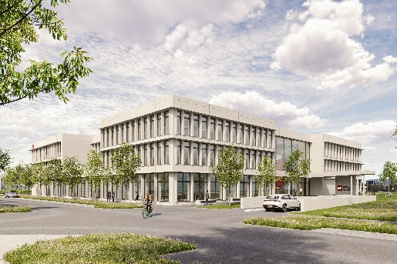  Image source: Würth Elektronik  Würth Elektronik moves into the Hightech Innovation Center in Munich. | 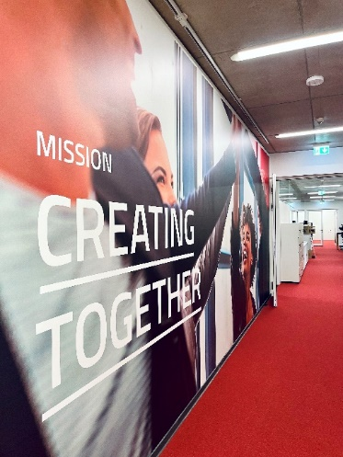 Image source: Würth Elektronik  Würth Elektronik’s mission “Creating Together” is also reflected in the new building.

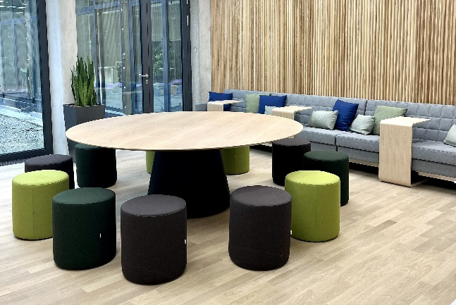  Image source: Würth Elektronik  Many new seating options invite to be together. | 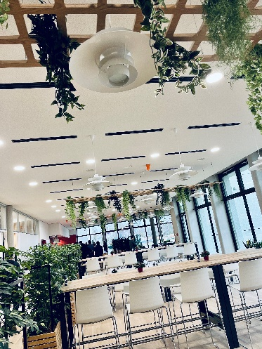  Image source: Würth Elektronik  The staff restaurant "BaWEria" provides for the physical well-being of the employees.

About the Würth Elektronik eiSos Group
Würth Elektronik eiSos Group is a manufacturer of electronic and electromechanical components for the electronics industry and a technology company that spearheads pioneering electronic solutions. Würth Elektronik eiSos is one of the largest European manufacturers of passive components and is active in 50 countries. Production sites in Europe, Asia and North America supply a growing number of customers worldwide.
The product range includes EMC components, inductors, transformers, RF components, varistors, capacitors, resistors, quartz crystals, oscillators, power modules, Wireless Power Transfer, LEDs, sensors, connectors, power supply elements, switches, push-buttons, connection technology, fuse holders and solutions for wireless data transmission.
The unrivaled service orientation of the company is characterized by the availability of all catalog components from stock without minimum order quantity, free samples and extensive support through technical sales staff and selection tools.
Würth Elektronik is part of the Würth Group, the global market leader in the development, production, and sale of fastening and assembly materials, and employs 8,000 people. In 2021, the Würth Elektronik eiSos Group generated sales of 1.09 Billion Euro in 2021.
Würth Elektronik: more than you expect!
Further information at www.we-online.com

Further information:  Würth Elektronik eiSos GmbH & Co. KG  Sarah Hurst  Max-Eyth-Strasse 1  74638 Waldenburg  Germany  Phone: +49 7942 945-5186  E-mail: sarah.hurst@we-online.de  www.we-online.com | Press contact:  HighTech communications GmbH  Brigitte Basilio  Brunhamstrasse 21  81249 Munich  Germany  Phone: +49 89 500778-20  Telefax: +49 89 500778-77  E-mail: b.basilio@htcm.de  www.htcm.de

