PRESS RELEASE

Würth Elektronik LED offer: WL-SUMW and WL-SUTW
More powerful UV-C LEDs for sterilization applications
Waldenburg (Germany), September 20, 2022—Würth Elektronik presents new products in the field of optoelectronics: The manufacturer of electronic and electromechanical components expands the WL-SUMW series with more powerful UV-C LEDs for sterilization applications and introduces UV-A LEDs with particularly low height under the designation WL-SUTW, which are used in horticulture.
The new components, like the entire range, are available immediately from stock and are also provided as free samples. Light distribution can be simulated using Rayfiles which can be downloaded from the online catalog as an additional service.
Powerful UV-C LEDs
The WL-SUMW product series from Würth Elektronik has been expanded to include two 275 nm UV-C LEDs, with higher optical powers of 20 and 50 mW. The UV-C LEDs can be used for sterilization, surface disinfection, water and air purification, among other applications.
The basics of disinfection with UV-C are explained in Application Note ANO008: Disinfection with UV-C LEDs.
New UV-A LED product series
The new WL-SUTW product series of UV-A LEDs is offered in the flat SMD design PLCC2 package and is available with wavelengths from 365nm to 405 nm. Typical applications for the UV-A LEDs include UV curing, sensing and counterfeit detection. In addition, the product range can also be used for special horticulture applications.
Wurth Elektronik provides comprehensive information on the subject of plant cultivation with LEDs and special light recipes on its Horticulture web page. Interested parties can also find application notes with detailed information below:
ANO002: LEDs - The future of horticulture lighting and
ANO003: Advantages of LED lighting in horticulture applications there.

Available images
The following images can be downloaded from the Internet in printable quality: https://kk.htcm.de/press-releases/wuerth/
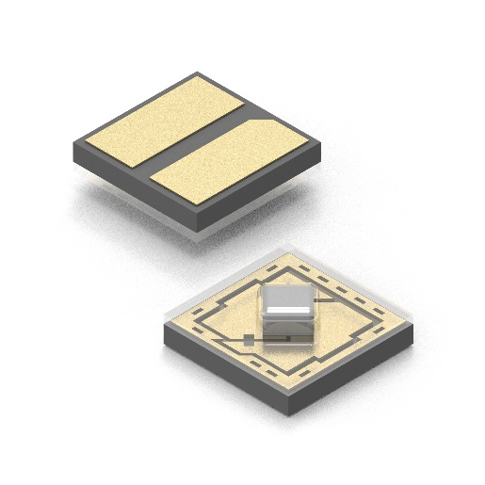Image source: Würth Elektronik  The new UV-C LEDs of the WL-SUMW product series. | 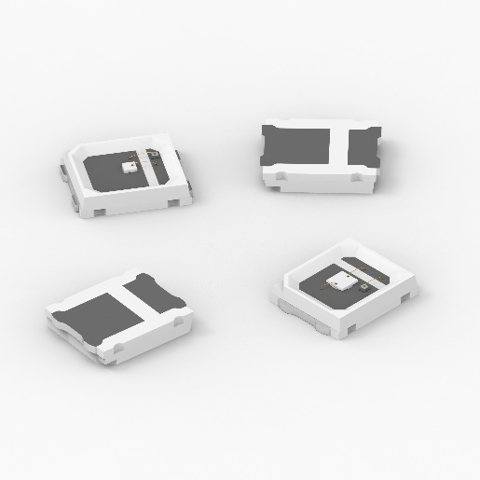Image source: Würth Elektronik  The new UV-A LEDs of the WL-SUTW product series.

About the Würth Elektronik eiSos Group
Würth Elektronik eiSos Group is a manufacturer of electronic and electromechanical components for the electronics industry and a technology company that spearheads pioneering electronic solutions. Würth Elektronik eiSos is one of the largest European manufacturers of passive components and is active in 50 countries. Production sites in Europe, Asia and North America supply a growing number of customers worldwide.
The product range includes EMC components, inductors, transformers, RF components, varistors, capacitors, resistors, quartz crystals, oscillators, power modules, Wireless Power Transfer, LEDs, sensors, connectors, power supply elements, switches, push-buttons, connection technology, fuse holders and solutions for wireless data transmission.
The unrivaled service orientation of the company is characterized by the availability of all catalog components from stock without minimum order quantity, free samples and extensive support through technical sales staff and selection tools.

Würth Elektronik is part of the Würth Group, the world market leader for assembly and fastening technology. The company employs 8,000 staff and generated sales of 1.09 Billion Euro in 2021.
Würth Elektronik: more than you expect!
Further information at www.we-online.com

Further information:  Würth Elektronik eiSos GmbH & Co. KG  Sarah Hurst  Max-Eyth-Strasse 1  74638 Waldenburg  Germany  Phone: +49 7942 945-5186  E-mail: sarah.hurst@we-online.de  www.we-online.com | Press contact:  HighTech communications GmbH  Brigitte Basilio  Brunhamstrasse 21  81249 Munich  Germany  Phone: +49 89 500778-20  Telefax: +49 89 500778-77  E-mail: b.basilio@htcm.de  www.htcm.de

