PRESS RELEASE
Würth Elektronik and UnternehmerTUM invited to the MakerSpace
This is where Start-ups are accelerated
Waldenburg (Germany), October 19, 2022 – Würth Elektronik gives makers a chance: On October 13, the event “WE support your idea – Würth Elektronik meets MakerSpace” took place in Munich.
Developers quickly reach their limits when it comes to getting their own project off the ground; this is where Würth Elektronik comes in. In cooperation with MakerSpace, the high-tech prototype workshop of Europe’s largest innovation and start-up center UnternehmerTUM, the electronics company gives start-ups, students, and makers the space to bring their own ideas to life. Technology, machines, software, and training are available. On October 13, Würth Elektronik held its first event in the high-tech workshop of the MakerSpace to showcase opportunities for the concrete implementation of projects: WE support your idea - Würth Elektronik meets MakerSpace.
In exciting sessions, more than 100 participants were able to find out how they can meet current challenges in the electronics industry, and which solutions will help them advance their projects. A tour of the MakerSpace offered additional insights into a wide range of opportunities for makers. The event was opened by Alexander Gerfer, CTO of Würth Elektronik eiSos, and Prof. Dr. Helmut Schönenberger, founder and CEO of UnternehmerTUM.
“We support the creative ideas in the MakerSpace because this is exactly how we see ourselves as a technology enabler. Young developers benefit from our expert knowledge and support an idea from its inception to market maturity,” says Gerfer.
UnternehmerTUM is the initiator of the project. “We want to provide start-up assistance for creative ideas and create an appropriate space for them,” comments Schönenberger. “In this context, MakerSpace should be taken literally – it is a place for makers.”
At the MakerSpace, creatives and startups have been receiving holistic support from Würth Elektronik as a cooperation partner of UnternehmerTUM since February 2022. As one of the largest manufacturers of electronic and electromechanical components in Europe, Würth Elektronik supports with expertise and components and advises on prototype development.
In an expert consultation session, inventors have the opportunity to explore technical solutions with electronics experts. Together with in-house engineers, innovators can also test the electronic functionality of their development.

Available images
The following images can be downloaded from the Internet in printable quality: https://kk.htcm.de/press-releases/wuerth/
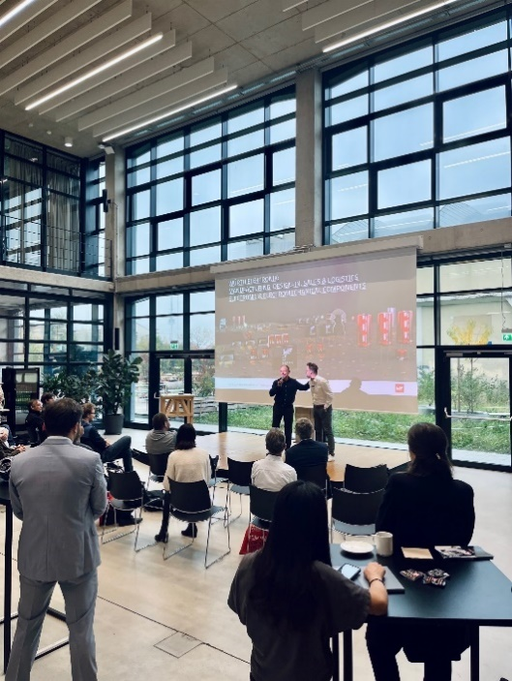Image source: Würth Elektronik  Alexander Gerfer, CTO of Würth Elektronik eiSos, explains how start-ups and makers are supported in the development of prototypes. | 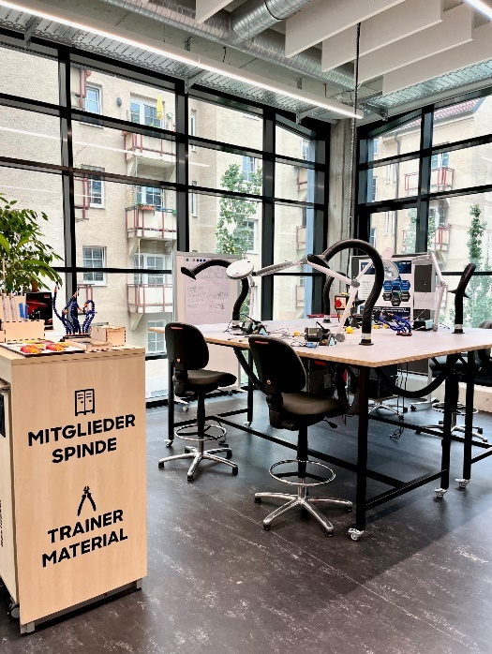  Image source: Würth Elektronik  The MakerSpace is a high-tech workshop and offers access to new machines, tools and software.

MakerSpace – A paradise for inventors and creatives.
MakerSpace is a publicly accessible high-tech workshop that gives ambitious startups, Do-It-Yourselfers and creative people access to machines, tools and software as well as a creative community.
The workshop was opened in 2015 as a subsidiary of UnternehmerTUM, Europe’s largest center for innovation and start-ups, and offers a place where ideas and innovations can be realized in the form of prototypes and small series. Different work areas are available, such as machine, metal and wood workshops, as well as textile and electrical processing. 3D printers, laser cutters and water jet cutting machines can be used to create new shapes and process all materials. For support and networking, MakerSpace offers training and consulting services as well as events for members.
MakerSpace is located at two sites: with 1,500 m² at the Garching Research Campus and, since 2021, with 1,200 m² at the Munich Urban Colab startup center, centrally located in the Creative Quarter in Munich.

About the Würth Elektronik eiSos Group
Würth Elektronik eiSos Group is a manufacturer of electronic and electromechanical components for the electronics industry and a technology company that spearheads pioneering electronic solutions. Würth Elektronik eiSos is one of the largest European manufacturers of passive components and is active in 50 countries. Production sites in Europe, Asia and North America supply a growing number of customers worldwide.
The product range includes EMC components, inductors, transformers, RF components, varistors, capacitors, resistors, quartz crystals, oscillators, power modules, Wireless Power Transfer, LEDs, sensors, connectors, power supply elements, switches, push-buttons, connection technology, fuse holders and solutions for wireless data transmission.
The unrivaled service orientation of the company is characterized by the availability of all catalog components from stock without minimum order quantity, free samples and extensive support through technical sales staff and selection tools.
Würth Elektronik is part of the Würth Group, the world market leader for assembly and fastening technology. The company employs 8,000 staff and generated sales of 1.09 Billion Euro in 2021.
Würth Elektronik: more than you expect!
Further information at www.we-online.com

Further information:  Würth Elektronik eiSos GmbH & Co. KG  Sarah Hurst  Max-Eyth-Strasse 1  74638 Waldenburg  Germany  Phone: +49 7942 945-5186  E-mail: sarah.hurst@we-online.de  www.we-online.com | Press contact:  HighTech communications GmbH  Brigitte Basilio  Brunhamstrasse 21  81249 Munich  Germany  Phone: +49 89 500778-20  Telefax: +49 89 500778-77  E-mail: b.basilio@htcm.de  www.htcm.de

