PRESS RELEASE
Würth Elektronik expands its WR-TBL range of terminal block connectors
Following the wire-protection principle and in the 10-mm pitch
Waldenburg (Germany), October 27, 2022—Würth Elektronik adds new products in the 10-mm pitch to expand its WR-TBL Series of terminal block connectors designed according to the wire-protection principle of: three series of THT terminal blocks with screw fastening. Two of the connector series have horizontal wire entries, one has vertical wire entries. The number of pins ranges from one to ten. The insulation material used to make the robust terminal is PA66 with a flammability rating of UL94 V-0, while stainless steel is used as the wire-clamping material. The operating temperature ranges from -40°C to +105°C.
The products in the “WR-TBL Series 1018 - 10.00 mm Modular Horizontal Cable Entry” are certified according to UL and VDE for 16 A and have a working voltage of 250 V.
The terminal block connectors in the “WR-TBL Series 1028 - 10.00 mm Modular Horizontal Cable Entry” are approved for 15 A (cULus) and 17.5 A (VDE) applications, with working voltages of 300 V (cULus) and 250 V (VDE) respectively.
The “WR-TBL Series 1068 - 10.00 mm Modular Vertical Cable Entry” completes the range, with cULus certification for 16 A and 250 V.
The new blue terminal blocks are available from stock without a minimum order quantity, and free samples are available on request.

Available images
The following images can be downloaded from the Internet in printable quality: https://kk.htcm.de/press-releases/wuerth/

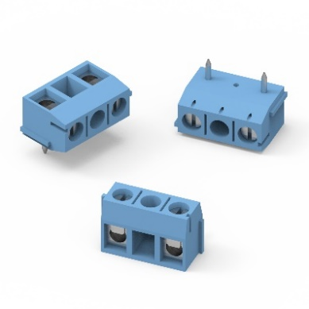
THT terminal block series with screw fastening
Image source: Würth Elektronik

About the Würth Elektronik eiSos Group
Würth Elektronik eiSos Group is a manufacturer of electronic and electromechanical components for the electronics industry and a technology company that spearheads pioneering electronic solutions. Würth Elektronik eiSos is one of the largest European manufacturers of passive components and is active in 50 countries. Production sites in Europe, Asia and North America supply a growing number of customers worldwide.
The product range includes EMC components, inductors, transformers, RF components, varistors, capacitors, resistors, quartz crystals, oscillators, power modules, Wireless Power Transfer, LEDs, sensors, connectors, power supply elements, switches, push-buttons, connection technology, fuse holders and solutions for wireless data transmission.
The unrivaled service orientation of the company is characterized by the availability of all catalog components from stock without minimum order quantity, free samples and extensive support through technical sales staff and selection tools.
Würth Elektronik is part of the Würth Group, the world market leader for assembly and fastening technology. The company employs 8,000 staff and generated sales of 1.09 Billion Euro in 2021.
Würth Elektronik: more than you expect!
Further information at www.we-online.com

Further information:  Würth Elektronik eiSos GmbH & Co. KG  Sarah Hurst  Max-Eyth-Strasse 1  74638 Waldenburg  Germany  Phone: +49 7942 945-5186  E-mail: sarah.hurst@we-online.de  www.we-online.com | Press contact:  HighTech communications GmbH  Brigitte Basilio  Brunhamstrasse 21  81249 Munich  Germany  Phone: +49 89 500778-20  Telefax: +49 89 500778-77  E-mail: b.basilio@htcm.de  www.htcm.de

