PRESS RELEASE
Würth Elektronik extends its range of coaxial products
High-frequency connectors: SMA, RPSMA, cables, and adapters
Waldenburg (Germany), October 6, 2022—Würth Elektronik has extended its portfolio of coaxial connectors, rounding off its already comprehensive Coax Connector Portfolio. The SMA connectors are specifically designed for a frequency range up to 18 GHz at an impedance of 50 Ω. Thanks to their threaded coupling technology, they are ideally suited as data lines in environments subject to strong vibration. They are certified as a standard interface acc. to MIL-STD-348 and are characterized by their extremely sophisticated production techniques (CNC-milled down to a tolerance of 0.003 mm, gold-plated contacts).
These new additions to the product range include SMA and RPSMA bulkhead jacks with threaded coupling technology, a straight socket, also with regular and reverse polarity, THT connectors and end-launch connectors for PCB top-edge mounting – all of the IP67 protection class. New items also include the right-angled SMA adapter WR-ADPT and a series of variants of the RPSMA cable plug fitted with various types of cable (RG174/U, RG-178/U, RG316/U), each in the standard lengths of 152 mm and 305 mm.
All connector articles are available from stock at Würth Elektronik. The supplier also offers custom-assembly services on request.

Available images
The following images can be downloaded from the Internet in printable quality: https://kk.htcm.de/press-releases/wuerth/
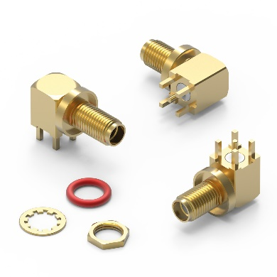
SMA and RPSMA bulkhead connectors with threaded coupling technology
Image source: Würth Elektronik

About the Würth Elektronik eiSos Group
Würth Elektronik eiSos Group is a manufacturer of electronic and electromechanical components for the electronics industry and a technology company that spearheads pioneering electronic solutions. Würth Elektronik eiSos is one of the largest European manufacturers of passive components and is active in 50 countries. Production sites in Europe, Asia and North America supply a growing number of customers worldwide.
The product range includes EMC components, inductors, transformers, RF components, varistors, capacitors, resistors, quartz crystals, oscillators, power modules, Wireless Power Transfer, LEDs, sensors, connectors, power supply elements, switches, push-buttons, connection technology, fuse holders and solutions for wireless data transmission.
The unrivaled service orientation of the company is characterized by the availability of all catalog components from stock without minimum order quantity, free samples and extensive support through technical sales staff and selection tools.
Würth Elektronik is part of the Würth Group, the world market leader for assembly and fastening technology. The company employs 8,000 staff and generated sales of 1.09 Billion Euro in 2021.
Würth Elektronik: more than you expect!
Further information at www.we-online.com

Further information:  Würth Elektronik eiSos GmbH & Co. KG  Sarah Hurst  Max-Eyth-Strasse 1  74638 Waldenburg  Germany  Phone: +49 7942 945-5186  E-mail: sarah.hurst@we-online.de  www.we-online.com | Press contact:  HighTech communications GmbH  Brigitte Basilio  Brunhamstrasse 21  81249 Munich  Germany  Phone: +49 89 500778-20  Telefax: +49 89 500778-77  E-mail: b.basilio@htcm.de  www.htcm.de

