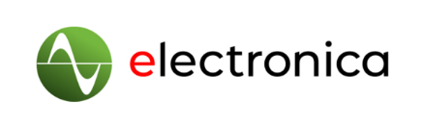
PRESS RELEASE
15–18 November 2022
Hall A5, Stand 406

Würth Elektronik at electronica 2022
From Components to Design-in Support
Waldenburg (Germany), September 22, 2022—Würth Elektronik will be exhibiting at electronica from November 15 to 18, 2022. At its 400 m² stand 406 in Hall A5 at Messe München, the manufacturer of electronic and electromechanical components will have themed islands with personal consultation, where the focus will not only be on component solutions but also on individual design-in advice. The trade fair is all about the company's "more than you expect" promise. Würth Elektronik not only has a wide range of components in its portfolio, but also stands out because of its comprehensive range of services.
In addition to the presentation of numerous new products and innovations from the areas of passive components, electromechanics, optoelectronics, power modules, thermal management, radio modules, sensors and automotive, the focus is on design-in support for customers. Experts from Würth Elektronik will be available to provide practical advice on key decision-making parameters for component selection. They will address the requirements of typical industry applications, such as industrial electronics, automotive or EMS, and give practical solutions for standard and customized components. Würth Elektronik will also present and explain joint reference designs with semiconductor manufacturers at the show. The free online simulation platform REDEXPERT will also be a topic at the show.
"We see ourselves as a partner to our customers and supply not only components - directly from stock - but an overall concept," affirms Alexander Gerfer, CTO of the Würth Elektronik eiSos Group. "This combination of functional product, specifications based on measured values and design recommendations puts developers in a position to find the perfect solution quickly and easily with our components - we are also demonstrating this with our electronica presence."
True to the company motto "more than you expect," Würth Elektronik will be hosting a get-together at its booth after the trade show from Tuesday to Thursday from 6:00-8:00 p.m. each day, where trade show visitors can end the evening together.

Available images
The following images can be downloaded from the Internet in printable quality: https://kk.htcm.de/press-releases/wuerth/
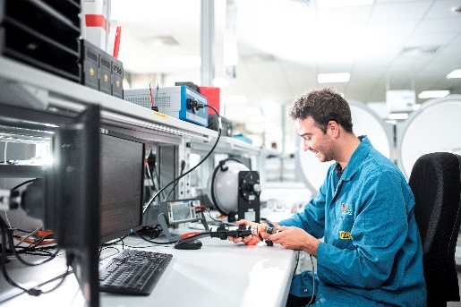Image source: Würth Elektronik  Würth Elektronik's state-of-the-art laboratories not only develop new electronic components, but also gather know-how on their optimal application - data sheets, for example, are usually based on empirical measured values. | 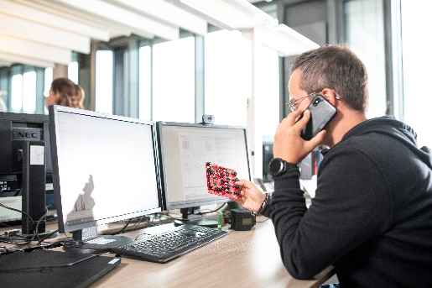Image source: Würth Elektronik  From development boards and the free online simulation platform REDEXPERT to personal consulting and design-in support, Würth Elektronik provides its customers with a wide range of support services.

About the Würth Elektronik eiSos Group
Würth Elektronik eiSos Group is a manufacturer of electronic and electromechanical components for the electronics industry and a technology company that spearheads pioneering electronic solutions. Würth Elektronik eiSos is one of the largest European manufacturers of passive components and is active in 50 countries. Production sites in Europe, Asia and North America supply a growing number of customers worldwide.
The product range includes EMC components, inductors, transformers, RF components, varistors, capacitors, resistors, quartz crystals, oscillators, power modules, Wireless Power Transfer, LEDs, sensors, connectors, power supply elements, switches, push-buttons, connection technology, fuse holders and solutions for wireless data transmission.
The unrivaled service orientation of the company is characterized by the availability of all catalog components from stock without minimum order quantity, free samples and extensive support through technical sales staff and selection tools.
Würth Elektronik is part of the Würth Group, the world market leader for assembly and fastening technology. The company employs 8,000 staff and generated sales of 1.09 Billion Euro in 2021.

Würth Elektronik: more than you expect!
Further information at www.we-online.com

Further information:  Würth Elektronik eiSos GmbH & Co. KG  Sarah Hurst  Max-Eyth-Strasse 1  74638 Waldenburg  Germany  Phone: +49 7942 945-5186  E-mail: sarah.hurst@we-online.de  www.we-online.com | Press contact:  HighTech communications GmbH  Brigitte Basilio  Brunhamstrasse 21  81249 Munich  Germany  Phone: +49 89 500778-20  Telefax: +49 89 500778-77  E-mail: b.basilio@htcm.de  www.htcm.de

