PRESS RELEASE

Würth Elektronik Honored in Employer Study for Second Year in a Row
Diversity and Equality in Electronics
Waldenburg (Germany), October 28, 2022—Waldenburg, 28 October 2022 – Würth Elektronik has once again scored outstandingly in the Brigitte-employer study. With an overall score of 4 out of 5 possible points, the manufacturer of electronic and electromechanical components is among the top of 281 companies surveyed. In 80 questions, the organizations’ efforts on the subject of equality were queried in five areas, including reconciliation of work and family life, flexibility of work, career promotions, and the importance of transparency and equality.
“Each time, this award is confirmation for us of what we have achieved and motivation for further efforts. We were particularly pleased that this time we were able to improve on transparency and equality,” says Lorena Haigis, responsible for employer branding at Würth Elektronik eiSos. Vanessa Stein in HR, who is responsible for the area of living situations, gives an example of the progress. “Incidentally, how well you can reconcile work and family at Würth Elektronik is also evident among our male employees: Compared to last year, more fathers are working part-time for us, and more fathers are also taking parental leave.”
“We operate in a male-dominated industry. So it remains a challenge to increase the proportion of women in management positions. But, we are on a good path. Our mentoring program for career development is very well received and used,” Stein continued. “We are pleased to receive the award because it shows that we are driving equality forward. I would be pleased if we could arouse the interest of one or two future female applicants as a result.”
Team of experts developed questions
Five renowned female experts developed the questionnaire for the study by Brigitte-magazine and the employer branding agency, Territory Embrace. These experts include multiple supervisory board member and senior advisor Janina Kugel, the Scientific Director of the Hans Böckler Foundation’s Institute of Economics and Social Sciences, Prof. Dr. Bettina Kohlrausch, the Fair Pay expert, Henrike von Platen, Ana-Cristina Grohnert, chairwoman of the board of the employer initiative “Charta der Vielfalt” and Susanne Hüsemann, managing director of Queb, the federal association for employer branding, personnel marketing and recruiting.

Available images
The following images can be downloaded from the Internet in printable quality: https://kk.htcm.de/press-releases/wuerth/
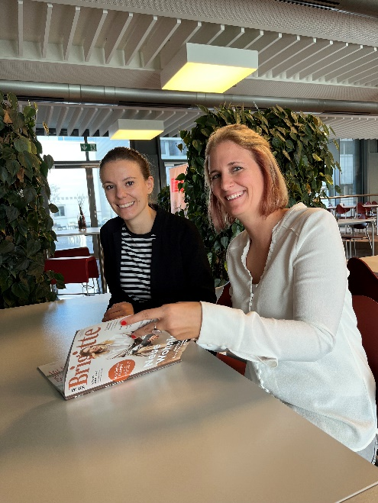Image source: Würth Elektronik
Lorena Haigis, Employer Branding, and Vanessa Stein, HR (from left to right), responsible among other things for the area of living situations, are pleased with the good results in the Brigitte study.

About the Würth Elektronik eiSos Group
Würth Elektronik eiSos Group is a manufacturer of electronic and electromechanical components for the electronics industry and a technology company that spearheads pioneering electronic solutions. Würth Elektronik eiSos is one of the largest European manufacturers of passive components and is active in 50 countries. Production sites in Europe, Asia and North America supply a growing number of customers worldwide.
The product range includes EMC components, inductors, transformers, RF components, varistors, capacitors, resistors, quartz crystals, oscillators, power modules, Wireless Power Transfer, LEDs, sensors, connectors, power supply elements, switches, push-buttons, connection technology, fuse holders and solutions for wireless data transmission.

The unrivaled service orientation of the company is characterized by the availability of all catalog components from stock without minimum order quantity, free samples and extensive support through technical sales staff and selection tools.
Würth Elektronik is part of the Würth Group, the world market leader for assembly and fastening technology. The company employs 8,000 staff and generated sales of 1.09 Billion Euro in 2021.
Würth Elektronik: more than you expect!
Further information at www.we-online.com

Further information:  Würth Elektronik eiSos GmbH & Co. KG  Sarah Hurst  Max-Eyth-Strasse 1  74638 Waldenburg  Germany  Phone: +49 7942 945-5186  E-mail: sarah.hurst@we-online.de  www.we-online.com | Press contact:  HighTech communications GmbH  Brigitte Basilio  Brunhamstrasse 21  81249 Munich  Germany  Phone: +49 89 500778-20  Telefax: +49 89 500778-77  E-mail: b.basilio@htcm.de  www.htcm.de

