PRESS RELEASE
Würth Elektronik publishes its application note on wireless communication
Decoupling High Frequency Signals from a DC Supply
Waldenburg (Germany), October 20, 2022 – Application notes from Würth Elektronik provide you with accurate information and practical tips. Not only for developers—the latest release ANP101: RF Gain Block Amplifier with Integrated Multilayer Ferrite Bead for Broadband Operation addresses how the transmission characteristics of an RF amplifier can be enhanced and improved by the right choice of components and an optimal layout.
From 5G systems to radio and antenna applications, wireless communication accompanies us throughout our daily lives. So the demand for universal high-frequency amplifiers is correspondingly high. By selecting the optimal passive components, the transmission characteristics of the amplifier can be improved during development. A well-designed layout further improves RF performance. The aim is to transmit both RF signals and the DC supply on a single line without interference or cross-talk. A key component is the inductor for decoupling the RF and DC supplies.
Measurement setup for evaluating circuit alternatives
Besides standard inductors, multilayer ferrites are also used. To compare and evaluate the two alternatives, Würth Elektronik specialists designed and tested a RF amplifier evaluation board. The setup and measurement results are documented in the application note. ANP101 also includes circuit design recommendations for setting the optimum parameters using two RF amplifier examples.
It also describes how to select components specifically with the online simulation tool REDEXPERT from Würth Elektronik or how to dimension the DC block capacitor correctly.
Application note ANP101 is available at http://www.we-online.com/ANP101.

Available images
The following images can be downloaded from the Internet in printable quality: https://kk.htcm.de/press-releases/wuerth/
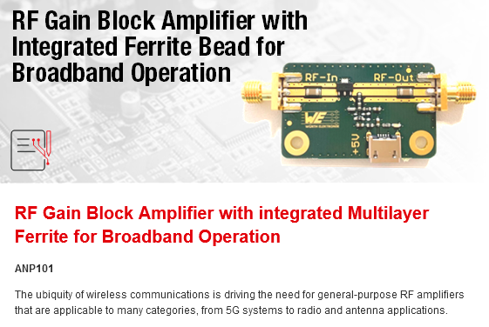  Image source: Würth Elektronik  Pro knowledge for RF developers: Würth Elektronik application note ANP101 | 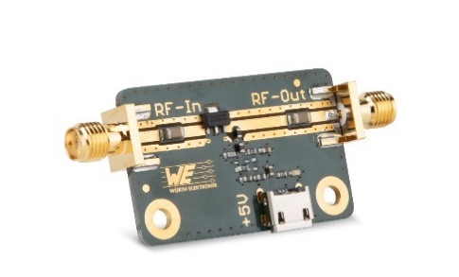  Image source: Würth Elektronik  Evaluation board for RF gain block amplifier: The setup and measurement results are documented precisely in the application note.

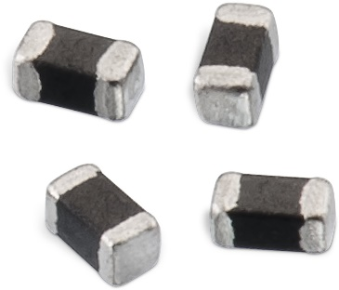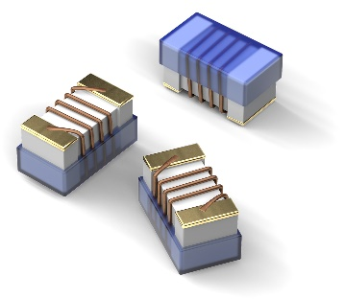
Image source: Würth Elektronik
Components in comparison: WE-CBF HF multilayer ferrite components (left), wound ceramic inductors WE-KI SMT (right)

About the Würth Elektronik eiSos Group
Würth Elektronik eiSos Group is a manufacturer of electronic and electromechanical components for the electronics industry and a technology company that spearheads pioneering electronic solutions. Würth Elektronik eiSos is one of the largest European manufacturers of passive components and is active in 50 countries. Production sites in Europe, Asia and North America supply a growing number of customers worldwide.
The product range includes EMC components, inductors, transformers, RF components, varistors, capacitors, resistors, quartz crystals, oscillators, power modules, Wireless Power Transfer, LEDs, sensors, connectors, power supply elements, switches, push-buttons, connection technology, fuse holders and solutions for wireless data transmission.
The unrivaled service orientation of the company is characterized by the availability of all catalog components from stock without minimum order quantity, free samples and extensive support through technical sales staff and selection tools.
Würth Elektronik is part of the Würth Group, the world market leader for assembly and fastening technology. The company employs 8,000 staff and generated sales of 1.09 Billion Euro in 2021.
Würth Elektronik: more than you expect!
Further information at www.we-online.com

Further information:  Würth Elektronik eiSos GmbH & Co. KG  Sarah Hurst  Max-Eyth-Strasse 1  74638 Waldenburg  Germany  Phone: +49 7942 945-5186  E-mail: sarah.hurst@we-online.de  www.we-online.com | Press contact:  HighTech communications GmbH  Brigitte Basilio  Brunhamstrasse 21  81249 Munich  Germany  Phone: +49 89 500778-20  Telefax: +49 89 500778-77  E-mail: b.basilio@htcm.de  www.htcm.de

