Cellutronik: Sustainable circuit carriers made of bacterial cellulose
Research project develops bio-based PCB materials and digital manufacturing processes for the electronics of the future

Niedernhall, June 1, 2026 – With the launch of the collaborative project “Cellutronik” in November 2025, funded by the German Federal Ministry of Research, Technology and Space (BMFTR), Würth Elektronik Circuit Board Technology is setting another milestone toward sustainable electronics solutions. Together with the Institute for Materials Science at the University of Stuttgart and the Hahn-Schickard-Gesellschaft für angewandte Forschung e.V., the consortium aims to develop innovative bio-based circuit carriers for next-generation electronic applications.

At the core of the project is the use of bacterial cellulose as an alternative base material for printed circuit boards. In laboratory settings, it is produced from agricultural waste such as, for example, potato peels or okara through the targeted use of microorganisms and subsequently processed into stable, sheet-like substrates. This approach opens promising opportunities to replace conventional petroleum-based materials in the long term and significantly reduce environmental impact across the entire lifecycle of electronic products.

The Institute for Materials Science at the University of Stuttgart is developing suitable synthesis processes for producing the cellulose fibers. Würth Elektronik Circuit Board Technology contributes its extensive expertise in PCB technology, investigating how established manufacturing processes can be adapted and further developed for these new materials. The goal is to ensure early industrial feasibility and combine technological innovation with practical application.

A further key component is the development of additive manufacturing methods by Hahn-Schickard. Using advanced digital printing technologies, conductive structures are applied directly onto the cellulose surfaces. Inkjet printing of copper and silver inks creates conductive traces precisely where they are needed. This approach reduces material usage, waste, and process time while enabling new levels of design freedom in PCB development. Both the bio-based substrates and the printed conductive structures are solderable, enabling integration of electronic components and compatibility with existing manufacturing processes.

The project consistently follows the R&D philosophy of Würth Elektronik Circuit Board Technology: innovation is not developed in isolation, but holistically aligned with real customer requirements and industrial processes. Close collaboration between research institutions and industrial application ensures that new technologies not only work in the lab but also deliver sustainable value in practice.

At the conclusion of the project, a demonstrator will showcase the production of multilayer PCBs based on bacterial cellulose and digital printing processes. This will demonstrate that high-performance, sustainable circuit carriers are both technologically feasible and environmentally advantageous. The long-term vision is to enable electronics solutions that leave no environmental impact at the end of their lifecycle, contributing meaningfully to a more resource-efficient future.

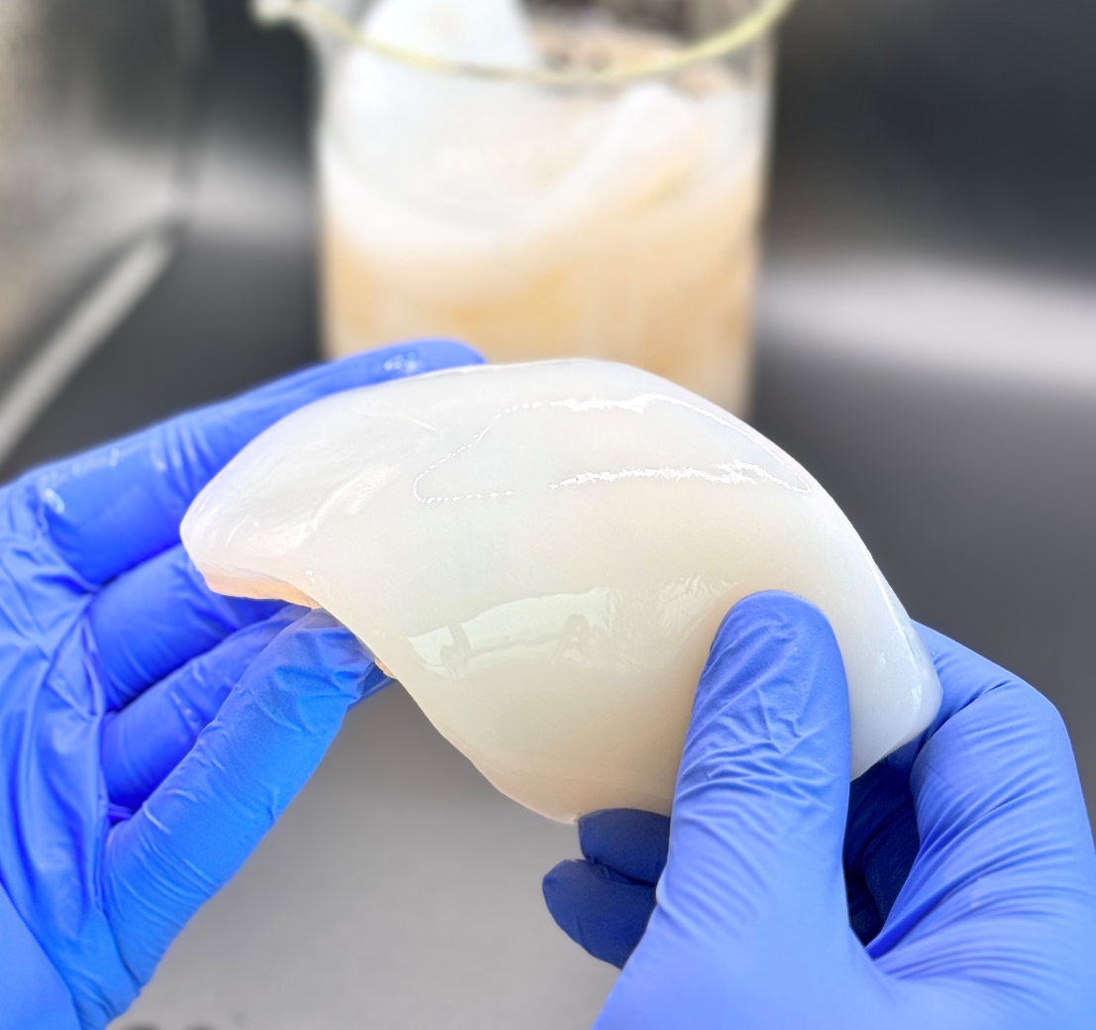
Image 1: Substrate based on bacterial cellulose directly from the laboratory (Source: Hahn-Schickard-Gesellschaft für angewandte Forschung e.V., Stuttgart)

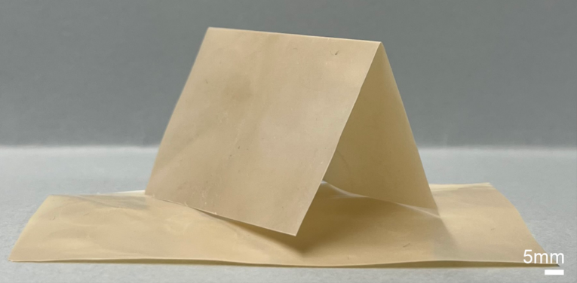
Image 2: Bacterially produced cellulose after drying (Source: University of Stuttgart – Institute for Materials Science)

About Würth Elektronik Circuit Board Technology
Founded in 1971, Würth Elektronik Circuit Board Technology is one of Europe’s leading PCB manufacturers, with national and international sales teams, around 4,000 customers, and annual sales in the three-digit million euro range.
Production takes place at German sites as well as with qualified partners in Asia. From basic to high-end technologies, the company delivers customer-specific solutions ranging from prototypes and samples to medium and large-scale production. Through the development of innovative product technologies, the company positions itself as a market pioneer.
Experts from a wide range of disciplines provide intensive consulting and support—from the initial idea through to the finished product and beyond. Serving both individual entrepreneurs and large corporations, Würth Elektronik Circuit Board Technology positions itself as a reliable partner. The portfolio is complemented by an online shop enabling 24/7 PCB ordering.

Würth Elektronik. More than you expect!

More information: https://www.we-online.com/pcb
YouTube: https://www.we-online.com/youtube
LinkedIn: https://www.linkedin.com/company/wuerth-elektronik-group
Instagram: https://www.instagram.com/we_group/

