PRESS RELEASE

Würth Elektronik presents its MagI³C-FIMM Fixed Isolated MicroModule
An Isolated Power Module in a MicroModule Package
Waldenburg (Germany), November 9, 2022—Würth Elektronik has extended the product families of its MagI³C power modules with the MagI³C-FIMM Fixed Isolated MicroModule. It combines the features of an isolated power module with those of a MicroModule in an LGA-7 package and measures just 9 mm x 7 mm x 3.1 mm. The isolation capacitance between the primary and secondary windings is typically just 8pF. The 1 W output power is maintained up to an ambient temperature of 100°C without derating. It represents one of the best modules in the portfolio of fully isolated modules—with an efficiency up to 91%.
MagI³C Power Modules are fully integrated DC/DC converters with switching power stage, controller, inductor as well as input/output capacitors. It requires no external circuitry—all components, including C_{IN} and C_{OUT}, are integrated, allowing quick and easy circuit design without transformer expertise.
MagI³C-FIMM boasts a small size and high efficiency, as well as an extended operating ambient temperature range up to 125°C. The module offers continuous short-circuit protection and overvoltage protection up to 3000 V.
Low radiated and conducted EMI
MagI³C-FIMM is suitable for applications in data acquisition, test and measurement technology, for supplying interfaces and microcontrollers, and other requirements in industrial electronics, to name but a few. It provides functional isolation for overvoltage protection and minimizes ground loops and ground shifts as well as noise in the signal path or sensor systems. According to the manufacturer's measurements, the low radiated EMI with tested filter combination is below the EN55032 Class B / CISPR-32 limits. The MicroModule is certified according to the current UL standard UL62368-1.
Developers can now order free samples and an evaluation board is available. MagI³C-FIMM is available from stock without a minimum order quantity.

Available images
The following images can be downloaded from the Internet in printable quality: https://kk.htcm.de/press-releases/wuerth/
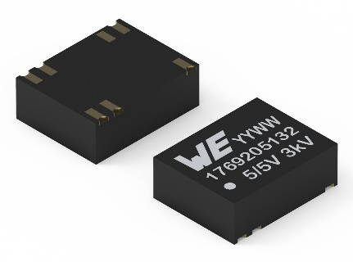
Image source: Würth Elektronik
MagI³C-FIMM Fixed Isolated MicroModule, an integrated DC/DC converter from Würth Elektronik

About the Würth Elektronik eiSos Group
Würth Elektronik eiSos Group is a manufacturer of electronic and electromechanical components for the electronics industry and a technology company that spearheads pioneering electronic solutions. Würth Elektronik eiSos is one of the largest European manufacturers of passive components and is active in 50 countries. Production sites in Europe, Asia and North America supply a growing number of customers worldwide.
The product range includes EMC components, inductors, transformers, RF components, varistors, capacitors, resistors, quartz crystals, oscillators, power modules, Wireless Power Transfer, LEDs, sensors, connectors, power supply elements, switches, push-buttons, connection technology, fuse holders and solutions for wireless data transmission.
The unrivaled service orientation of the company is characterized by the availability of all catalog components from stock without minimum order quantity, free samples and extensive support through technical sales staff and selection tools.

Würth Elektronik is part of the Würth Group, the world market leader for assembly and fastening technology. The company employs 8,000 staff and generated sales of 1.09 Billion Euro in 2021.
Würth Elektronik: more than you expect!
Further information at www.we-online.com

Further information:  Würth Elektronik eiSos GmbH & Co. KG  Sarah Hurst  Max-Eyth-Strasse 1  74638 Waldenburg  Germany  Phone: +49 7942 945-5186  E-mail: sarah.hurst@we-online.de  www.we-online.com | Press contact:  HighTech communications GmbH  Brigitte Basilio  Brunhamstrasse 21  81249 Munich  Germany  Phone: +49 89 500778-20  Telefax: +49 89 500778-77  E-mail: b.basilio@htcm.de  www.htcm.de

