PRESS RELEASE

Maschinenraum Momentum 2023: clear pro-AI statement from Würth Elektronik
We are Still in the Driving Seat
Waldenburg (Germany), September 29, 2023 – Alexander Gerfer, CTO of Würth Elektronik eiSos, made a clear commitment to Germany as an AI business location at Maschinenraum Momentum [a network of nearly 60 family-owned Small and Midsize Enterprize (SMEs)] conference in Berlin on September 28. As a manufacturer of electrical and electronic components, Würth Elektronik sees itself as a supplier of components and know-how for innovative industry. One great example is the cooperation with CELUS – a cloud-based engineering platform.
The organizer refers to Maschinenraum Momentum 2023 as the “first conference by SMEs for SMEs”. It offers inspirational inputs as well as panels and in-depth topic tracks.
Alexander Gerfer was among the speakers and participants this year. The CTO of Würth Elektronik eiSos clearly positioned himself in favor of AI in both his presentation and in the discussion which followed. “As official forecasts clearly indicate, there will no longer be any job that does not involve AI applications in some way or other. I can completely endorse this prognosis: Artificial intelligence is coming – and it is set to revolutionize our lives, that much is certain. So it’s now up to us to exploit the enormous potential of this technology and for us to make use of it. We are still sitting in the driving seat – and that's where we have to stay. In order to continue to be progressive and forward-oriented, it’s essential to act decisively and make bold decisions at the right time.”
Components for AI designs
The cooperation with CELUS exemplifies where Würth Elektronik is headed. The deep-tech company has added Würth Elektronik's proven passive components to its cloud-based engineering platform database. CELUS uses the database to automate development of PCBs based on modern AI. “From my own experience, I know that many ideas fail because of a single missing component, and that in circuit design, a lot of time is still spent sifting through catalogs and reinventing the wheel,” Gerfer reports. “But, we can no longer afford to do this in times of rising demand and labor becoming scarcer. We at Würth Elektronik keep in touch with the times with our marketing concept. We want to enable innovation and turn ideas into market-ready products. AI concepts, like the CELUS platform, set the direction: The person has the idea; the machine handles the routine tasks for them. That’s the future of artificial intelligence.”
Quality over quantity
“SMEs generally don’t have big development departments, and so they have to deploy their manpower in a more focused and rational way,” adds Tobias Rappers, Managing Director of the conference organizer Maschinenraum. “AI-assisted design is reshuffling the cards, especially in competition with large enterprises. Innovation is no longer a question of quantity, but of quality.”
Alongside Alexander Gerfer, Prof. Christina Kratsch, Professor of Artificial Intelligence & Software Engineering at the University of Applied Sciences for Engineering and Economics (HTW) Berlin, and Dr. Simon Müller, Deep-Tech Entrepreneur at wattx, the SME development partner, participated in the panel discussion on AI. The question addressed was “How do we operationalize generative AI in SMEs?”
Important: Component availability
“The best design is worthless if the components designed for it are not available,” CELUS founder and CEO, Tobias Pohl stresses. “This makes cooperation with strong global players, like Würth Elektronik, all the more important for us. By having leading component manufacturers listed in our library, the engineers are able to find the best alternatives for their development work and circumvent chip shortages.”
Numerous new AI startups
“Germany as a business location is far better than its reputation, especially when it comes to AI,” Alexander Gerfer clearly affirms. "According to the ‘applied AI Institute for Europe’, the number of AI startups in this country is up by 67% in just one year. The renowned institute currently counts among more than 500 AI start-ups in Germany. We’ll support this positive trend proactively and specifically with our know-how and experience, as we have already done successfully in many other start-up fields.”

Available images
The following images can be downloaded from the Internet in printable quality: https://kk.htcm.de/press-releases/wuerth/
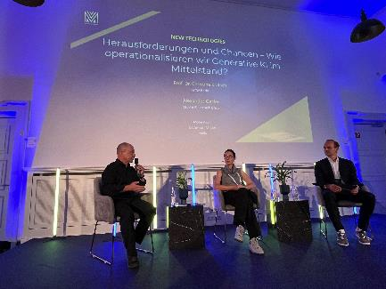Image source: Würth Elektronik  “Challenges and opportunities – How do we operationalize generative AI in SMEs?” was the theme of the Maschinenraum Momentum conference. On the panel (from left): Alexander Gerfer, CTO of Würth Elektronik eiSos, Prof. Christina Kratsch, Professor of Artificial Intelligence & Software Engineering at HTW Berlin, and moderator Dr. Simon Müller, deep-tech entrepreneur at the SME development partner wattx. | 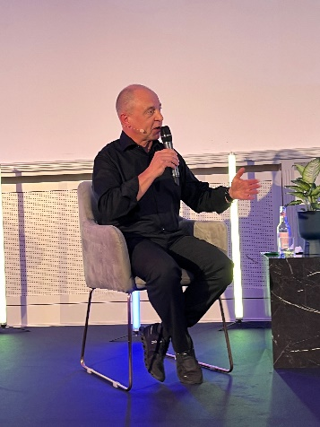Image source: Würth Elektronik  Alexander Gerfer, CTO of by Würth Elektronik eiSos at the conference: “Germany as a business location is far better than its reputation, especially when it comes to AI.”

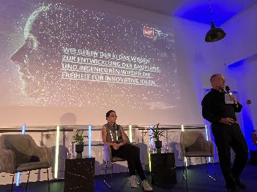Image source: Würth Elektronik
"We give AI the knowledge to develop the blueprints. And engineers the freedom for innovative ideas again," said Alexander Gerfer, CTO of Würth Elektronik eiSos at the conference.

About the Würth Elektronik eiSos Group
Würth Elektronik eiSos Group is a manufacturer of electronic and electromechanical components for the electronics industry and a technology company that spearheads pioneering electronic solutions. Würth Elektronik eiSos is one of the largest European manufacturers of passive components and is active in 50 countries. Production sites in Europe, Asia and North America supply a growing number of customers worldwide.
The product range includes EMC components, inductors, transformers, RF components, varistors, capacitors, resistors, quartz crystals, oscillators, power modules, Wireless Power Transfer, LEDs, sensors, radio modules, connectors, power supply elements, switches, push-buttons, connection technology, fuse holders and solutions for wireless data transmission.
The unrivaled service orientation of the company is characterized by the availability of all catalog components from stock without minimum order quantity, free samples and extensive support through technical sales staff and selection tools.
Würth Elektronik is part of the Würth Group, the global market leader in the development, production, and sale of fastening and assembly materials, and employs 8,200 people. In 2022, the Würth Elektronik Group generated sales of 1.33 Billion Euro.
Würth Elektronik: more than you expect!
Further information at www.we-online.com

Further information:  Würth Elektronik eiSos GmbH & Co. KG  Sarah Hurst  Clarita-Bernhard-Strasse 9  81249 Munich  Germany  Phone: +49 7942 945-5186  E-mail: sarah.hurst@we-online.de  www.we-online.com | Press contact:  HighTech communications GmbH  Brigitte Basilio  Brunhamstrasse 21  81249 Munich  Germany  Phone: +49 89 500778-20  E-mail: b.basilio@htcm.de  www.htcm.de

Source: Tagesschau
Source: Federal Ministry for Digital Affairs and Transport (BMdV)

