PRESS RELEASE

Würth Elektronik’s virtual conference Digital WE Days 2023
Four Days of Invaluable Electronics Knowledge Online
Waldenburg (Germany), September 21, 2023 – On 16 to 19 October 2023, Würth Elektronik will host its fifth Digital WE Days – a virtual conference that will bring in-depth, first-hand electronics expertise to the screen. Renowned Würth Elektronik specialists and partner companies will present high-caliber presentations on EMC, power management and electromechanics, wireless power, optoelectronics, and many other topics. In addition to the English language presentations, there will be the opportunity to pick up more detailed information in interactive Q&A sessions following each lecture. Registration for this free event is now open at www.we-online.com/digital-we-days.
“Our philosophy ‘More than you expect!’ takes center stage at this event, because we are more than just a component supplier,” Alexander Gerfer, CTO of Würth Elektronik eiSos, explains. “We proactively support our customers in solving their problems while providing expertise on the product. So, it comes as no surprise that our ever-expanding community has firmly established this event in its calendar.”
Concise technical knowledge and discussion
During Digital WE Days, Würth Elektronik offers customers and developers, and those interested, a unique opportunity to gain a comprehensive overview of the current state of the art, as well as the latest developments and perspectives in electronics. Partner presentations from onsemi, KDPOF, ST Microelectronics, Texas Instruments and Rohde & Schwarz will join Würth Elektronik’s technical experts in presenting. Each of the 30+ technical presentations will take approximately 30 minutes and will cover topics such as power supply, EMC, filter calculation, power module design, thermal management on printed circuit boards, and much more besides. After each presentation, participants will have the chance to engage directly and personally with the experts in a wide-ranging live Q&A session.
Registration now open
Digital WE Days 2023 is a free service from Würth Elektronik. All presentations can be booked individually.
Information about the presentation program, the respective topic areas, as well as registration, is now available at www.we-online.com/digital-we-days.

Available images
The following images can be downloaded from the Internet in printable quality: https://kk.htcm.de/press-releases/wuerth/
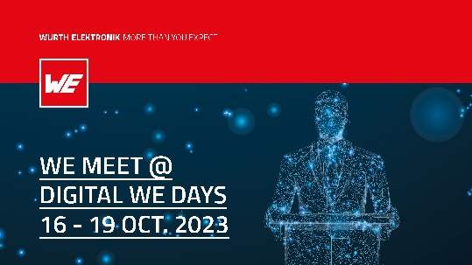  Image source: Würth Elektronik  The Digital WE Days – Virtual Conference will take place October 16 - 19. | 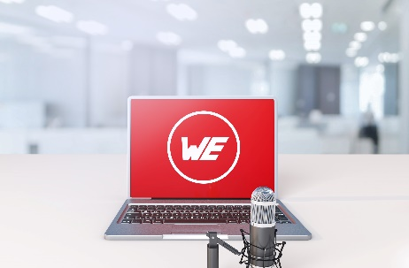  Image source: Würth Elektronik  Digital WE Days 2023: a varied programme with informative presentations and subsequent live Q&A sessions on EMC, power management, electromechanics, wireless power, optoelectronics, and many other topics.

About the Würth Elektronik eiSos Group
Würth Elektronik eiSos Group is a manufacturer of electronic and electromechanical components for the electronics industry and a technology company that spearheads pioneering electronic solutions. Würth Elektronik eiSos is one of the largest European manufacturers of passive components and is active in 50 countries. Production sites in Europe, Asia and North America supply a growing number of customers worldwide.
The product range includes EMC components, inductors, transformers, RF components, varistors, capacitors, resistors, quartz crystals, oscillators, power modules, Wireless Power Transfer, LEDs, sensors, radio modules, connectors, power supply elements, switches, push-buttons, connection technology, fuse holders and solutions for wireless data transmission.
The unrivaled service orientation of the company is characterized by the availability of all catalog components from stock without minimum order quantity, free samples and extensive support through technical sales staff and selection tools.

Würth Elektronik is part of the Würth Group, the global market leader in the development, production, and sale of fastening and assembly materials, and employs 8,200 people. In 2022, the Würth Elektronik Group generated sales of 1.33 Billion Euro.
Würth Elektronik: more than you expect!
Further information at www.we-online.com

Further information:  Würth Elektronik eiSos GmbH & Co. KG  Sarah Hurst  Clarita-Bernhard-Strasse 9  81249 Munich  Germany  Phone: +49 7942 945-5186  E-mail: sarah.hurst@we-online.de  www.we-online.com | Press contact:  HighTech communications GmbH  Brigitte Basilio  Brunhamstrasse 21  81249 Munich  Germany  Phone: +49 89 500778-20  E-mail: b.basilio@htcm.de  www.htcm.de

