PRESS RELEASE

Microsoft Azure-certified IoT design kit from Würth Elektronik
The faster route to smart systems
Waldenburg (Germany), September 12, 2023 – With its new Calypso IoT Design Kit, Würth Elektronik is proud to present an evaluation kit with pre-installed firmware, which enables the simple creation and evaluation of secure end-to-end IoT solutions using Microsoft’s Azure IoT Central. The design kit offers a robust hardware platform for rapid prototyping. The FeatherWing development board from Wurth Elektronik combines sensors, power modules and wireless connectivity into one simple kit. They are open source and are fully compatible with the Feather form factor from Adafruit. Hardware and software have been pre-tested and verified for integration into Microsoft’s Azure IoT central, to which end Würth Elektronik has joined the Azure Certified Device program.
The Calypso IoT Design Kit comprises the Würth Elektronik FeatherWing sensor, the Würth Elektronik Calypso Wi-Fi FeatherWing, and Adafruit’s FeatherWing OLED and Feather M0, which works with the ATSAMD21G18 ARM Cortex M0+ processor and is supplied with pre-installed firmware from Würth Elektronik. The Calypso IoT Design Kit makes it easy to develop IoT applications, in particular for the decentralized recording of sensor data, which are then processed using the pre-installed UX und API interface Azure IoT Central. The FeatherWing sensor precisely monitors MEMS absolute-pressure, 3-axis acceleration, temperature, and relative-humidity sensors from Würth Elektronik. The Calypso IoT Design Kit can be used, for instance, to develop monitoring and control applications for areas such as industrial automation, the healthcare sector, smart home, smart cities, smart grids, and smart farming. Würth Elektronik recently showcased the last of these potential applications at exhibitions, where the company presented connected vertical farming prototypes for indoor cultivation with LEDs.
A major contribution
“We have joined the Azure Certified Device Program to ensure that customers can swiftly implement IoT solutions using hardware and software tools that have been pre-tested and verified for integration into Azure IoT,” explains Adithya Madanahalli, IoT Engineer at Würth Elektronik eiSos in the business unit for Wireless Connectivity & Sensors. “This is a major contribution to our full-service approach in supporting developers in the implementation of innovative technological applications“, adds Oliver Opitz, Vice President Wireless Connectivity & Sensors at Würth Elektronik eiSos.
The Calypso IoT Design Kit , which is available now, can be easily combined with other FeatherWings in Würth Elektronik’s and Adafruit’s product portfolios.

Available images
The following images can be downloaded from the Internet in printable quality: https://kk.htcm.de/press-releases/wuerth/
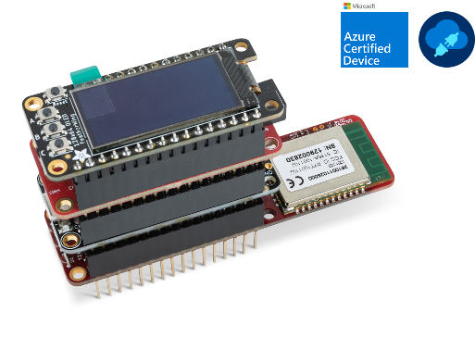
Image source: Würth Elektronik
Calypso IoT Design Kit

About the Würth Elektronik eiSos Group
Würth Elektronik eiSos Group is a manufacturer of electronic and electromechanical components for the electronics industry and a technology company that spearheads pioneering electronic solutions. Würth Elektronik eiSos is one of the largest European manufacturers of passive components and is active in 50 countries. Production sites in Europe, Asia and North America supply a growing number of customers worldwide.
The product range includes EMC components, inductors, transformers, RF components, varistors, capacitors, resistors, quartz crystals, oscillators, power modules, Wireless Power Transfer, LEDs, sensors, radio modules, connectors, power supply elements, switches, push-buttons, connection technology, fuse holders and solutions for wireless data transmission.
The unrivaled service orientation of the company is characterized by the availability of all catalog components from stock without minimum order quantity, free samples and extensive support through technical sales staff and selection tools.
Würth Elektronik is part of the Würth Group, the global market leader in the development, production, and sale of fastening and assembly materials, and employs 8,200 people. In 2022, the Würth Elektronik Group generated sales of 1.33 Billion Euro.
Würth Elektronik: more than you expect!
Further information at www.we-online.com

Further information:  Würth Elektronik eiSos GmbH & Co. KG  Sarah Hurst  Clarita-Bernhard-Strasse 9  81249 Munich  Germany  Phone: +49 7942 945-5186  E-mail: sarah.hurst@we-online.de  www.we-online.com | Press contact:  HighTech communications GmbH  Brigitte Basilio  Brunhamstrasse 21  81249 Munich  Germany  Phone: +49 89 500778-20  E-mail: b.basilio@htcm.de  www.htcm.de

