PRESS RELEASE

Würth Elektronik offers sulfur-resilient resistors
Black Silver: Not Only an Aesthetic Problem
Waldenburg (Germany), April 4, 2024 – WRIS-RSKS Anti-Sulfur Resistors is the name under which Würth Elektronik presents its new family of more than 500 resistors whose outstanding feature is their resilience to sulfur. The range is aimed at manufacturers of durable electronics for applications susceptible to exposure from sulfur compounds. These are found in the transportation sector, mining, refineries, agriculture, the chemical industry, and metal processing.
Silver is used for the resistor contacts as it combines the highest electrical and thermal conductivity while preventing oxide formation. In conventional resistors, however, the silver of the inner electrode can react to form silver sulfide in sulfurous environments. This has a negative impact on conductivity and can even lead to component failure in some cases. Anti-sulfur resistors from Würth Elektronik have an additional layer of nickel-chromium alloy that protects the silver-based electrode from contact with sulfur gases.
The resistors’ sulfur resilience is designed for long-term reliability under harsh conditions and is tested in accordance with ASTM B-809. The operating temperature ranges from -55°C to +155°C. The SMT components come with resistance values from 1 Ω to 10 MΩ, temperature coefficients ±100, ±200 and -200~+400 ppm/°C, resistance tolerances of ±1% and ±5% and power ratings of 0.1 to 0.5 W.
There are 247 variants of Würth Elektronik’s sulfur-resilient thick film resistors available from stock as standard items with no minimum order quantity. Another 260 can be produced to order. The packages 0402, 0603, 0805, 1206, and 1210 are offered.

Available images
The following images can be downloaded from the Internet in printable quality: https://kk.htcm.de/press-releases/wuerth/

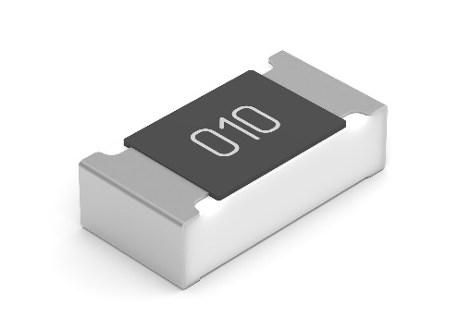  Image source: Würth Elektronik  WRIS-RSKS is the name for a new class of sulfur-resilient resistors from Würth Elektronik | 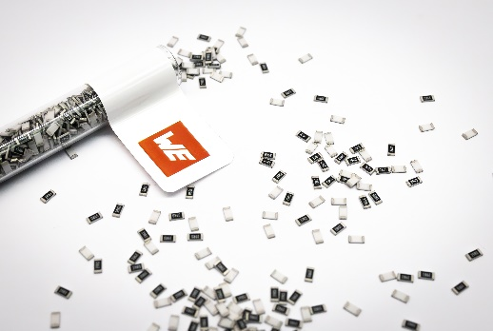Image source: Würth Elektronik  Under the name ‘WRIS-RSKS Anti-Sulfur Resistors’, Würth Elektronik presents its new family of more than 500 resistors whose outstanding feature is their resilience to sulfur.

About the Würth Elektronik eiSos Group
Würth Elektronik eiSos Group is a manufacturer of electronic and electromechanical components for the electronics industry and a technology company that spearheads pioneering electronic solutions. Würth Elektronik eiSos is one of the largest European manufacturers of passive components and is active in 50 countries. Production sites in Europe, Asia and North America supply a growing number of customers worldwide.
The product range includes EMC components, inductors, transformers, RF components, varistors, capacitors, resistors, quartz crystals, oscillators, power modules, Wireless Power Transfer, LEDs, sensors, radio modules, connectors, power supply elements, switches, push-buttons, connection technology, fuse holders and solutions for wireless data transmission. The portfolio is complemented by customized solutions.
The unrivaled service orientation of the company is characterized by the availability of all catalog components from stock without minimum order quantity, free samples and extensive support through technical sales staff and selection tools.
Würth Elektronik is part of the Würth Group, the global market leader in the development, production, and sale of fastening and assembly materials, and employs 7,900 people. In 2023, the Würth Elektronik Group generated sales of 1.24 Billion Euro.
Würth Elektronik: more than you expect!
Further information at www.we-online.com

Further information:  Würth Elektronik eiSos GmbH & Co. KG  Sarah Hurst  Clarita-Bernhard-Strasse 9  81249 Munich  Germany  Phone: +49 7942 945-5186  E-mail: sarah.hurst@we-online.de  www.we-online.com | Press contact:  HighTech communications GmbH  Brigitte Basilio  Brunhamstrasse 21  81249 Munich  Germany  Phone: +49 89 500778-20  E-mail: b.basilio@htcm.de  www.htcm.de

